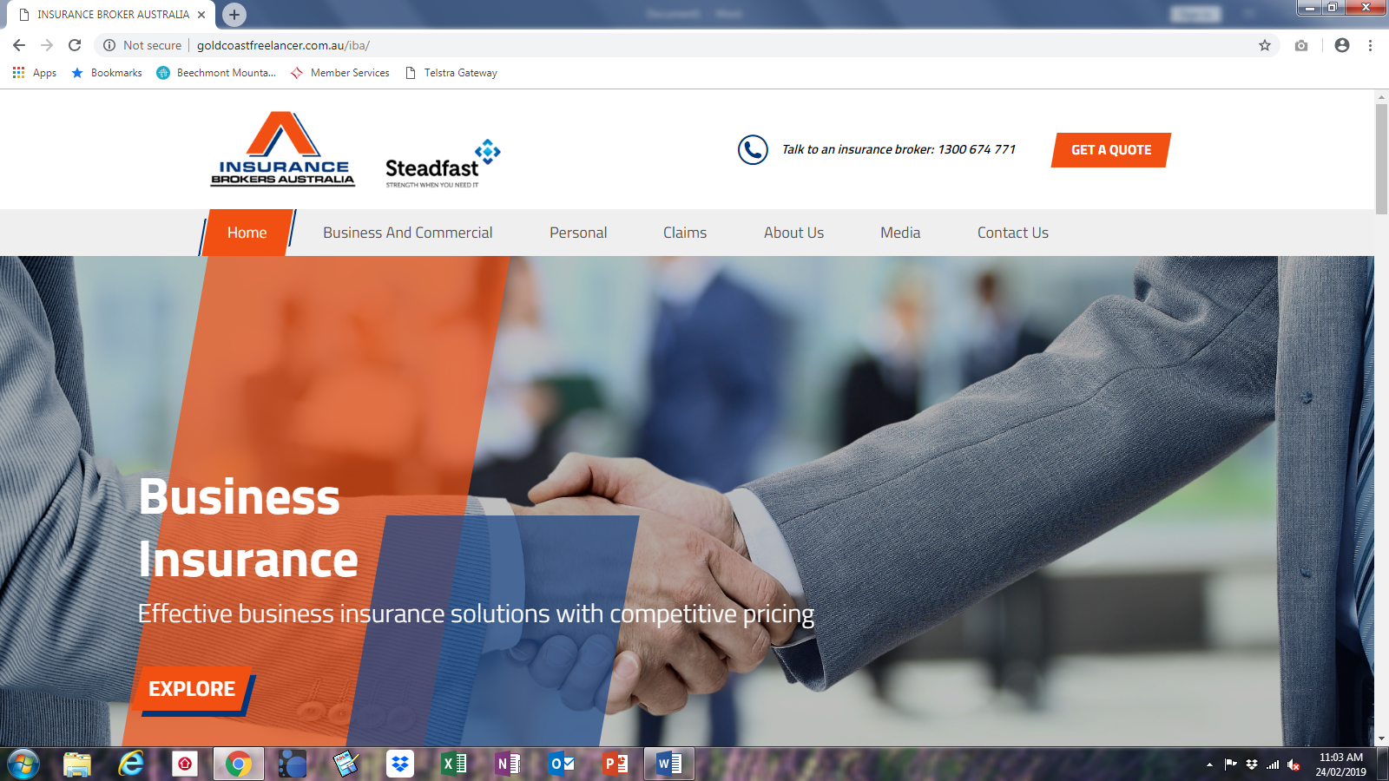

1. Effective> Comprehensive
2. Competitive> market leading premiums
3. ‘EXPLORE’

Our clients look to us to guide them in their choice of covers. We specialise in providing peace of mind, and we all do our best to carry out your work.

Accidents and mistakes do happen. Any business can be left without critical equipment, buildings, stock and infrastructure or be vulnerable to online attack, exposed to customer claims of negligence, injury or property damage.

As a specialist business broker, you can trust us to protect you against the many risks faced by business owners. Choose the products that are right for your business and create one single and comprehensive insurance package, tailored to your requirements.

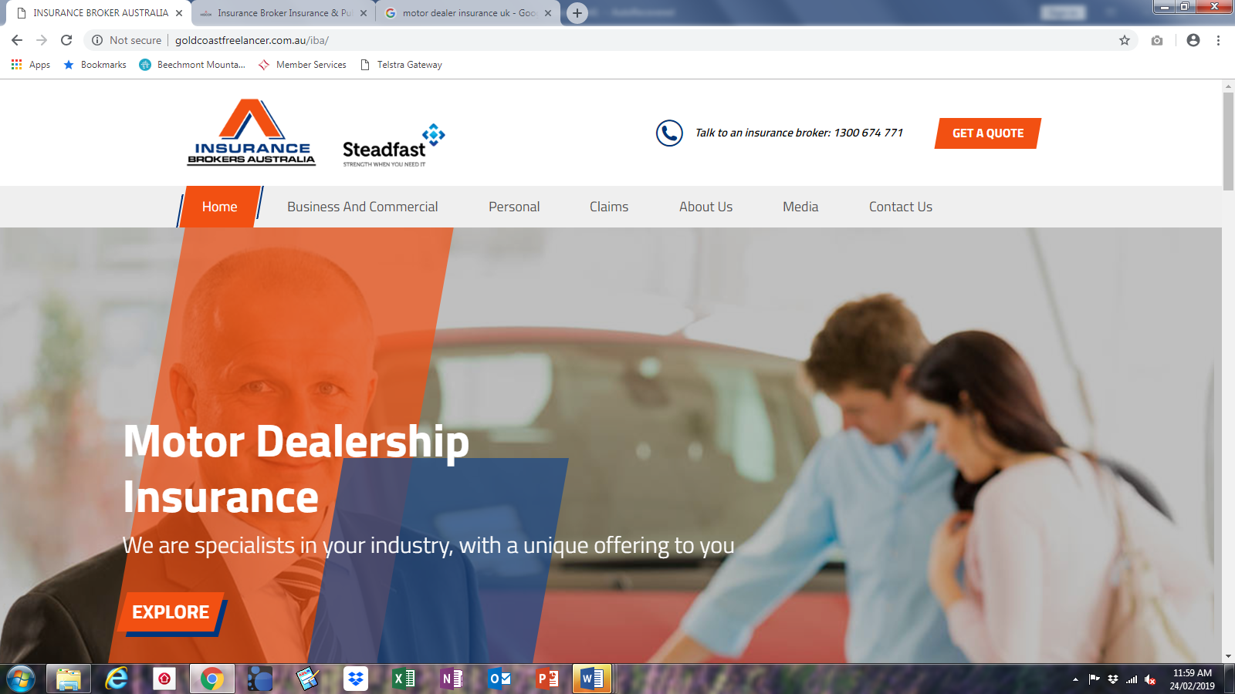

1. ‘with a unique offering to you> no one knows dealership like us
2. EXPLORE

**Dealership Pak**

Our dealership policies vary in scope to tailor for your location, size and stock. Depending on whether you operate from a new franchise showroom, ‘lockup’ factory or even wholesaling – our policy can be tailored to suit your requirements. Whilst buying and selling may be your primary occupation, our policy also allows for service and parts divisions and can be extended to cover personally owned vehicles as well. Our industry dealer Pak includes covers for-

* Cars, trucks, heavy transport and machinery
* Caravans and RV’s
* Motorcycles
* Farm and agricultural machinery

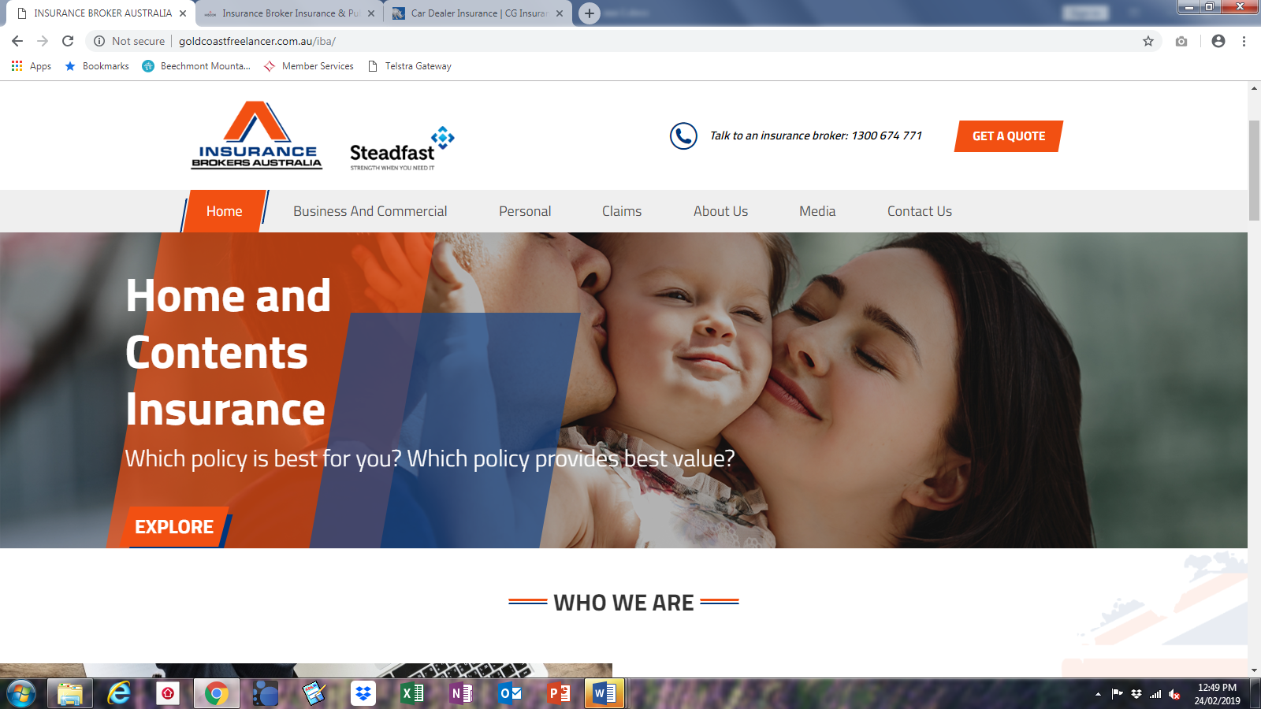

EXPLORE

Making a mistake when taking a policy out can lead to a rejected claim.

It can often feel like home insurers are trying to catch you out - and sometimes they are.

An innocent oversight on your part [will lead to a reduced payout](https://www.telegraph.co.uk/insurance/car/insurers-reveal-success-rates-on-claims-for-car-travel-and-home/), or not being compensated at all when something goes wrong.

Imagine, incorrectly estimating the total amount of insurance needed and you then see your claimed loss reduced even if it’s well within your coverage limit elected by you.

**‘r expertise’> typo in graphic**

**‘duty to you’> our …etc**

We work for you, not the insurer. It is our duty of care is to represent your best interests at all times.

HOW WE WORK? …tidy

# th

# thhally thhavailable from a direct insurer Minimising of your exposure to asset and liability loss Hps **About Us**

A business has an obligation to identify and assess foreseeable hazards. If it is not reasonably practical to eliminate the risk you must take steps to control the risk. As with your accountant or solicitor who are perceived as trusted advocates and true business partners in building the success of your investment, our Value Proposition to you is the service and risk management advice we provide:

* Highlighting the potential pitfalls for you so as to minimise your exposure to financial risks.
* Highlighting hazards and security issues to ensure adequate protection of your property and business.
* Helping improve and ‘insure’ your bottom line.

Insurance Brokers Australia is a leading business insurance provider of broking and financial services for business in Australia.

**Insurance Brokers Australia holds membership with:**

[](https://www.steadfast.com.au/)

[Visit website](https://www.steadfast.com.au/)

**Steadfast group limited**

In 1996, 43 privately owned insurance brokerages joined forces, united in the belief that quality advice and service were paramount in the insurance industry.  With that Steadfast was born, an Australian owned and operated enterprise.

Today Steadfast are the largest general insurance broker network in Australia & New Zealand, comprising over 348 brokerages with over 1,200 offices across metropolitan and regional areas.

Steadfast are an ASX 200 listed company, a market leader in their industry and an innovator in insurance broking. True to their original charter, Steadfast exists to drive an insurance broker network that provides unique professional services and advice to its clients.

Steadfast generated A$6 billion in sales in FY16 and the group looks after over 2 million policies for Australian and New Zealand businesses.

[](https://anziif.com/)

[Visit website](https://anziif.com/)

**ANZIIF**

The Australian and New Zealand Institute of Insurance and Finance is the leading membership, education, training and professional development organisation for the insurance and finance industry in the Asia-Pacific region.

ANZIIF partners with companies, government and non-profit organisations to provide a range of services that support professional excellence to enhance the standards, reputation and success of the industry and improve community understanding of insurance and finance.

Established in 1884, ANZIIF works with members in 50 countries and has offices in Australia, New Zealand and China.

us to be a true business partner in your future business success Insurance Brokers AWE Ar

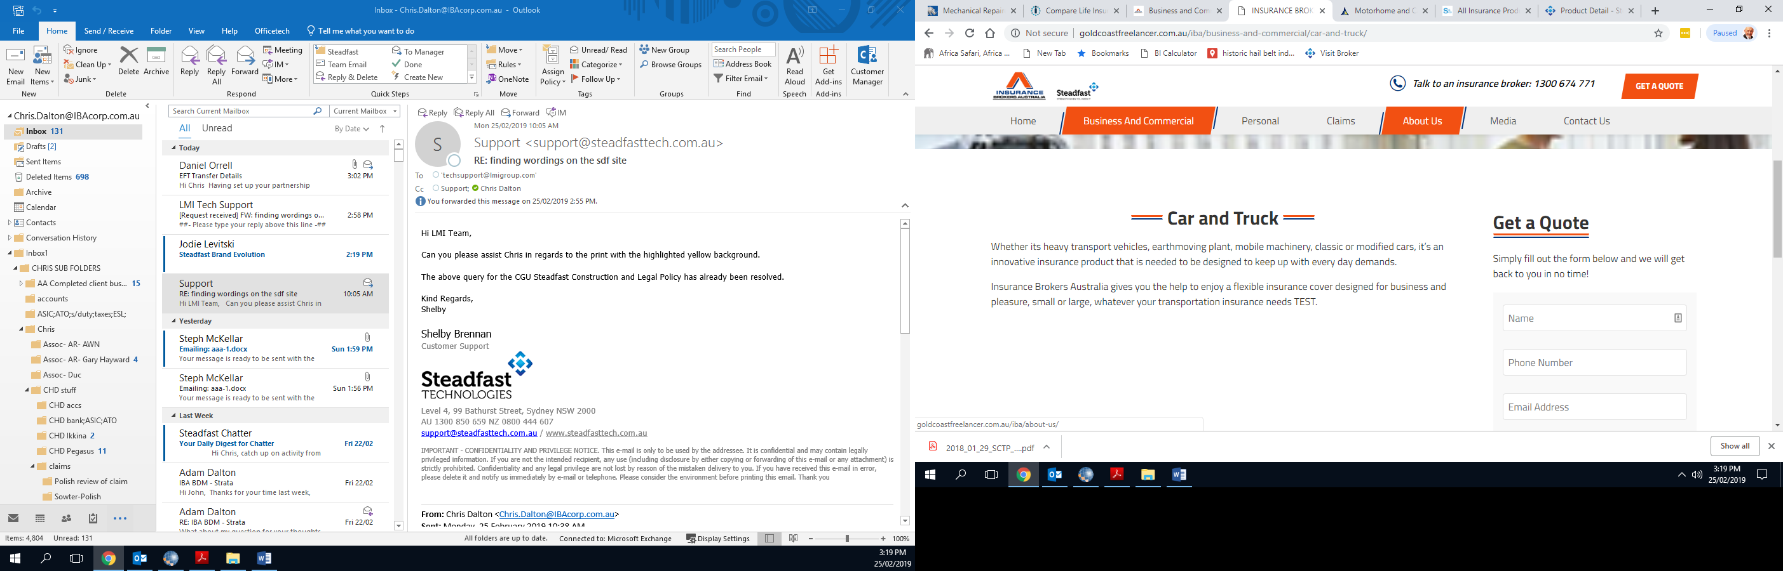

Insurance Brokers Australia advisers understand the pressure that Business owners and managers are under so we’ll take on the task of organising your vehicles & machinery. We will work with you to understand your specific requirements and conduct a thorough review of any existing fleet insurance arrangements you have in place to highlight any gaps in cover.

We work with the Australia’s leading insurers in motor fleet insurance and as an independent insurance broker, we can offer extremely competitive premiums and can often negotiate policy discounts and cover enhancements on behalf of our clients.

<https://www.sutcliffeinsurance.co.uk/http://www.sutcliffeinsurance.co.uk/all-insurance-products/fleet-insurance>

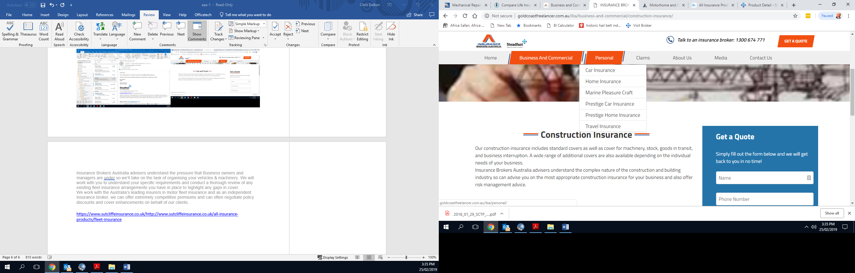

<https://www.towergateinsurance.co.uk/construction-insurance>

**Construction Insurance**

Specialist construction insurance covering a wide range of industries.

* Our wide client base spans most trades within construction, so we know the risks you face
* Our advisers can help with risk identification and assessment, contract reviews, programme audits and much more
* We can find a construction insurance policy tailored to you from a wide range of insurers
* [Features](https://www.towergateinsurance.co.uk/construction-insurance#features)
* [Claims](https://www.towergateinsurance.co.uk/construction-insurance#claims)
* [Guides](https://www.towergateinsurance.co.uk/construction-insurance#guides)
* [FAQs](https://www.towergateinsurance.co.uk/construction-insurance#faq)
* [**GET A QUOTE**](https://www.towergateinsurance.co.uk/construction-insurance/enquiry-form)
* 1300 674 771

Start your construction insurance quote online

[**GET A QUOTE**](https://www.towergateinsurance.co.uk/construction-insurance/enquiry-form)

Call us today to speak to a specialist construction insurance adviser

**1300 674 771**

Weekdays: 9am - 5pm  
Can’t get through right now? [Request a callback](https://www.towergateinsurance.co.uk/construction-insurance" \l "callback" \o "Request a callback)

## Features of our construction insurance

#### Construction insurance for any industry

We can provide cover across a range of different construction industries from house builders and project managers to scaffolding and roofing contractors and joinery manufacturers. We have experience working with construction professionals across many different areas and our relationship with major insurers means we combine expertise with cost effective construction insurance.

#### Bespoke construction insurance to suit you

We search the market to find you a policy that offers key features including public and products liability, environmental liability, advance loss of profits, latent defects, bonds and guarantees, and professional liability. Our aim is to build you the perfect construction insurance policy to suit your needs.

#### The right cover for your business

In order to provide the best construction insurance for your business we work to thoroughly understand your needs. As such our service typically includes risk identification and assessment, contract reviews, programme audits and design, claims management, and much more.

#### Prefer to spread the cost of your policy?

Paying by direct debit is an affordable and convenient way to pay for your construction insurance. Through our preferred provider, Premium Credit Limited (PCL), you have the option of setting up a Direct Debit to pay your premium in equal monthly instalments. To find out more about PCL and direct debit payments, select Direct Debit.

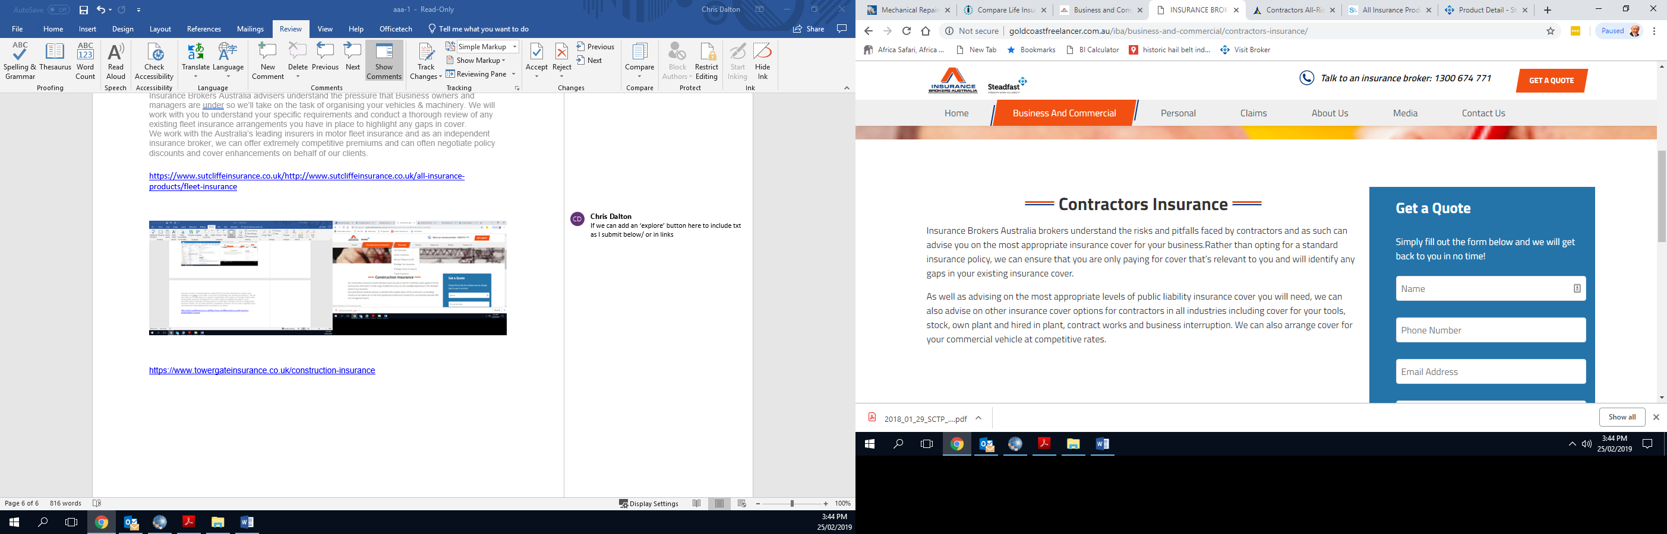

<https://www.towergateinsurance.co.uk/contractors-all-risk-insurance>

* Our contractors all-risk insurance covers contract works, hired-in plant, own plant and tools under one policy
* Contractors' liability cover to suit you, as part of a package or separately
* $20 million standard public liability cover; can be extended for high-risk contract works

## Features of our contractors all-risk insurance

#### Tailored contractors all-risk cover

* Our contractors all risk insurance can be tailored to your needs. As standard it covers contract works, hired in plant, own plant and tools. It can be extended to cover contracting in hazardous or high-risk areas.

#### Contract works insurance

* Contract works cover is included as standard in our contractors all-risk insurance. It provides liability protection against damage to works in progress from threats including fire, flood, storm, malicious damage and thefts.

#### Contractors insurance for high-risk work and hazardous locations

* Contractors cover is available for high-risk trades such as scaffolding, hot roofing and underpinning. We can also offer cover for contract work in hazardous or high-risk locations, if you require it.

#### Contractors public and employers' liability cover

* We provide public liability cover for contractors of $20million as standard, as well as employers' liability insurance. We can offer higher limits if you require it for specialist contract works. If professional indemnity insurance is required for your contract, we can also offer this under a separate policy.

Nearly every business is reliant upon technology and data but this makes us vulnerable. Traditional insurance might cover electronic equipment against fire, flood or theft, but it won’t cover what is really important if your systems are breached or data is lost.

Clearly prevention is important so we would encourage good cyber security, staff training and accreditations such as Cyber Essentials certification. But when things go wrong, as with other areas of your business, insurance should be there to minimise the costs and disruption. That is why cyber insurance is the fastest growing class of insurance.

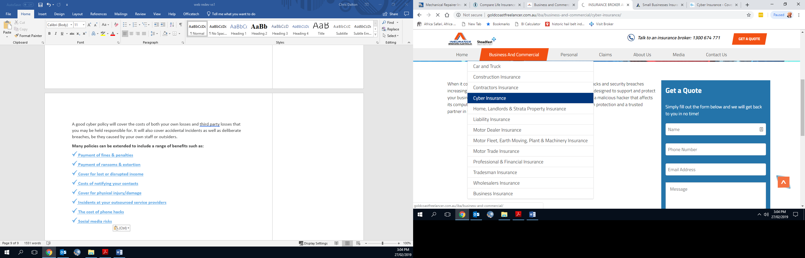

A good cyber policy will cover the costs of both your own losses and third party losses that may be held responsible for. It will also cover accidental incidents as well as deliberate breaches, be they caused by your own staff or outsiders.

**Many policies can be extended to include a range of benefits such as:**

[**[](http://www.sutcliffeinsurance.co.uk/all-insurance-products/cyber-insurance/) Payment of fines & penalties**](http://www.sutcliffeinsurance.co.uk/all-insurance-products/cyber-insurance/)

[**[](http://www.sutcliffeinsurance.co.uk/all-insurance-products/cyber-insurance/) Payment of ransoms & extortion**](http://www.sutcliffeinsurance.co.uk/all-insurance-products/cyber-insurance/)

[**[](http://www.sutcliffeinsurance.co.uk/all-insurance-products/cyber-insurance/business-interruption) Cover for lost or disrupted income**](http://www.sutcliffeinsurance.co.uk/all-insurance-products/cyber-insurance/business-interruption)

[**[](http://www.sutcliffeinsurance.co.uk/all-insurance-products/cyber-insurance/) Costs of notifying your contacts**](http://www.sutcliffeinsurance.co.uk/all-insurance-products/cyber-insurance/)

[**[](http://www.sutcliffeinsurance.co.uk/all-insurance-products/cyber-insurance/personal-accident) Cover for physical injury/damage**](http://www.sutcliffeinsurance.co.uk/all-insurance-products/cyber-insurance/personal-accident)

[**[](http://www.sutcliffeinsurance.co.uk/all-insurance-products/cyber-insurance/) Incidents at your outsourced service providers**](http://www.sutcliffeinsurance.co.uk/all-insurance-products/cyber-insurance/)

[**[](http://www.sutcliffeinsurance.co.uk/all-insurance-products/cyber-insurance/) The cost of phone hacks**](http://www.sutcliffeinsurance.co.uk/all-insurance-products/cyber-insurance/)

[**[](http://www.sutcliffeinsurance.co.uk/all-insurance-products/cyber-insurance/) Social media risks**](http://www.sutcliffeinsurance.co.uk/all-insurance-products/cyber-insurance/)

A good cyber policy will do so much more than present you with a cheque in the event of an incident; it will provide a comprehensive crisis management service along the following lines:

1. You experience a cyber or data incident
2. You contact your cyber insurance company who launches its crisis management procedure
3. Technical & forensic specialists are provided to pinpoint the problem, stop the problem and restore systems & data
4. Legal experts are appointed to ensure you respond in a compliant manner and act for you in any legal or regulatory disputes
5. Public Relations consultants act to minimise reputational damage and handle correspondence with your contacts, notifying them of the situation.
6. Fines & penalties paid
7. Defence costs & damages paid

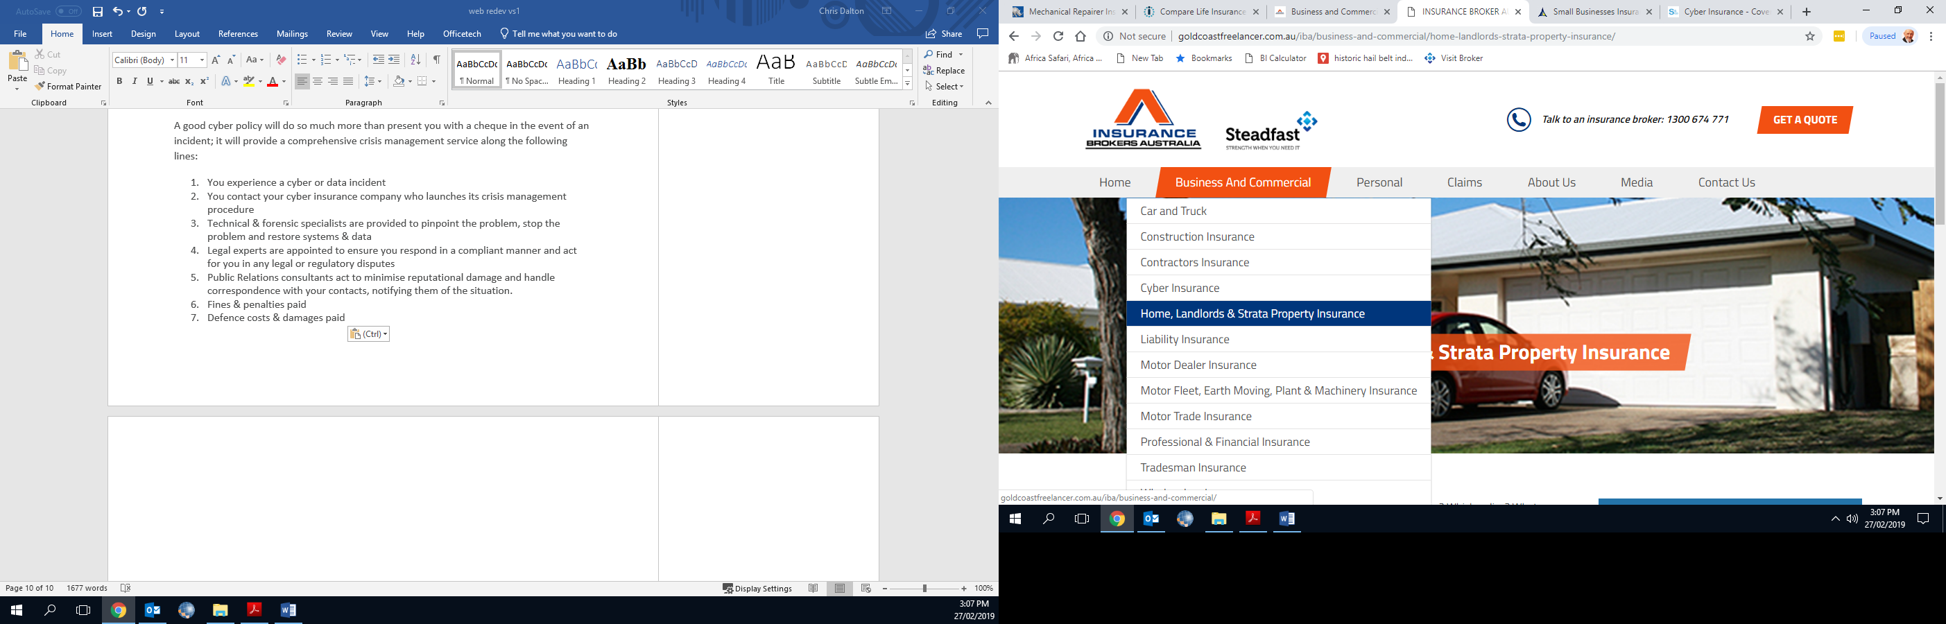

<https://www.qbe.com/au/home-insurance/landlord-insurance>

Home owners: how to avoid underinsurance

You know how important it is to insure your home and belongings, but are you sure you’ve got enough cover? We provide online insurance calculators to help you figure out how much cover you need (your ‘sum insured’).

[Read more](https://www.qbe.com/au/news/home-owners-avoiding-under-insurance)



Six ways to protect your home from thieves

Contents insurance can cover the cost of stolen belongings, but it can’t replace items of sentimental value or take away the trauma of a burglary. Proactivity is your best form of defence.



Home and contents insurance calculators

It's easy to underestimate the cost of rebuilding your home or replacing its contents. Our insurance calculators will help you figure out how much cover you need (your 'sum insured').

[Find out more](https://www.qbe.com/au/home-insurance/calculators)

Frequently Asked Questions

[What events am I covered for?](https://www.qbe.com/au/home-insurance/landlord-insurance" \l "291c6438-b11b-4aac-a8b9-07e4803d3b82)

[Can I cover damage caused by my tenants?](https://www.qbe.com/au/home-insurance/landlord-insurance" \l "6f42d6be-f232-487f-9ee5-425990a989ed)

[What about loss of rent?](https://www.qbe.com/au/home-insurance/landlord-insurance" \l "dc441f35-4c0f-4e6b-8c88-19d2beaf874c)

[What's legal liability cover?](https://www.qbe.com/au/home-insurance/landlord-insurance" \l "914b8cbf-0dd9-4d85-8659-1bafc91b625d)

[How do I make a claim?](https://www.qbe.com/au/home-insurance/landlord-insurance" \l "6d54b296-054e-48ab-8f8e-163977dfb646)

[How do I calculate my sum insured?](https://www.qbe.com/au/home-insurance/landlord-insurance" \l "93b9a118-bddf-47e3-969e-a3f9457cf7d2)

[Will my property be covered if I leave it unoccupied between tenants?](https://www.qbe.com/au/home-insurance/landlord-insurance" \l "4615418d-ebf0-47a4-a592-060378d588eb)

[Is fusion cover standard with your policy?](https://www.qbe.com/au/home-insurance/landlord-insurance" \l "9a23778a-a1bc-4d9e-8762-4f7273947975)

[Do you cover building costs?](https://www.qbe.com/au/home-insurance/landlord-insurance" \l "ae6714d9-03f0-45cd-bb87-d238250a0fbb)

Residential and commercial strata **insurance**, also called body corporate insurance, covers common contents and property under the management of a strata title or body corporate entity.

Owners of strata units typically share the **premium** costs of strata insurance as part of their strata fees and liabilities. Strata insurance is mandatory and must also provide public **liability** covering people that may be injured on common property.

Each state and territory has different legislative requirements that deal with insurance for strata title properties. Check that your insurance meets those legislative requirements. Your Body Corporate has a duty to insure the property and make sure the **policy** purchased meets the minimum legislative requirements.

What does strata insurance cover?

Strata insurance generally covers the building and common property and contents as defined on the title for the property. This might include common areas, garden equipment, wiring, lifts, swimming pools, car parks, walls, windows, gardens, ceilings and floors. These policies often have to cover common property that the average home policy does not.

Other common property that you might find is covered under strata insurance may include some of the fixed parts of your unit, such as ducted air conditioning, but it will not cover everything. If you own or lease a strata property you should read the policy carefully so that you understand what is not covered in your unit.

What does strata insurance typically NOT cover?

Strata insurance covers only common or shared property and may list certain exclusions, such as **coverage** against landslip or flood damage, or for the property’s fencing.  It is important to remember this type of insurance doesn’t cover the contents and personal items of unit holders or residents/tenants therin.

Make sure you have appropriate contents cover for your belongings, and for those other things strata insurance does not protect.

How much **excess** should we agree to?

Ask your strata manager or body corporate about the level of excess that has been negotiated with the insurer. It may help to work out how much it would cost to repair and rebuild the property in the event of a natural disaster, look at the limits in the policy, and work out from that how much excess the owners are prepared to pay.

What factors contribute to the premium?



In general, strata insurance costs the same or less for each unit owner than the premium paid by the owner of a stand-alone residence in the same area.

Each strata insurer develops and offers a unique commercial product in accordance with its **underwriting** appetite. Some common factors contributing to the premium include:

* Mandatory requirements of state-based law
* Government taxes on insurance (**stamp duty** and GST)
* The age and condition of the building
* The **replacement cost** of the building
* The **risk** profile of the location
* The claims history of the strata complex
* The vulnerability of the insured property to an insured event (age, building codes, building design and materials)
* Commercial activities carried out on the premises, such as holiday letting
* Fee and commissions from agents
* The level of excess payment selected by the body corporate, payable at the time of a claim
* The costs of common property, for example car parks, stairwells, fire protection systems, lifts and pools

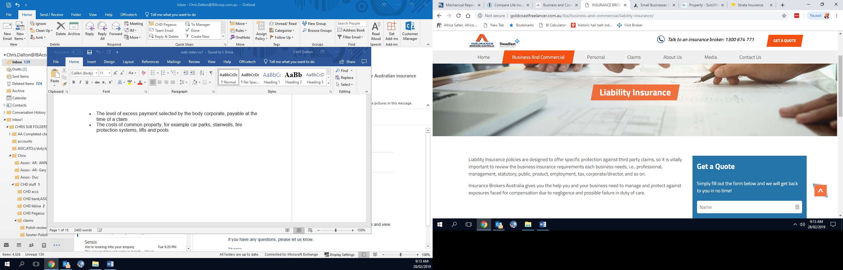

**Flexible cover limits**

Each business is different but for most, Public Liability Insurance is essential. For smaller businesses who work on smaller projects or with less interaction with the public, we can place lower, more suitable levels of cover for a lower premium. However, if you feel you need more cover, you can obtain suitable levels of $20 million or more. If you’re unsure how much cover you need, tell one of our knowledgeable brokers about your business and they’ll be able to help you get the right cover.

## Public Liability Insurance Claims

With Insurance Brokers Australia you can be confident that, in the event of the worst happening, your claim will be handled by a dedicated claims broker offering the fast and efficient service that you deserve.

Simply contact your public liability claims team using the details within your policy documents, or call us on 1300674771 and we will put you through to the best brokers. They will talk with you about your claim, guiding you through your next steps and taking you through the process. Furthermore, if you feel you need additional support or if you have concerns about the progression of your claim, we are always happy to hear your concerns.

<https://www.towergateinsurance.co.uk/liability/dynamic/public-liability-insurance?utm_campaign=googleppc&gclid=EAIaIQobChMI0PWslIbd4AIVDqmWCh1dGAYTEAAYASAAEgJOJfD_BwE&gclsrc=aw.ds>

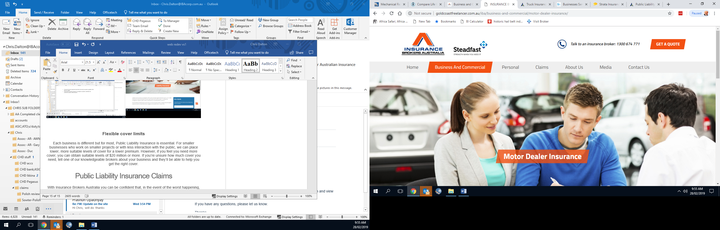

**Dealer Insurance**

Our dealer insurance policies vary in scope, shape and size. Depending on whether you operate from a showroom, small garage or even from home – our policy can be tailored to suit your requirements. Whilst buying and selling may be your primary business, our policy will also allow for vehicles being worked on by you, and can be extended to cover your personally owned vehicles as well.

Our dealer policies can include road risks, alongside liability cover as well as property and equipment. Our team are well versed in combining mixed usage as well – it is perfectly normal for a dealership to have other services on offer, including mechanical servicing alongside sales activities. Our dealer pak can encompass-

* High value stock and specified cover for more expensive vehicles
* Public and Product Liability up to $20 Million Indemnity Level.
* Equipment, machinery and plant – high sums insured.
* State Safety and modification certifications
* Road Risks for Motor Trade including recovery and movement of customers / own vehicles and extensions for secondary activities such as buying & selling.
* Office contents and other equipment, as well as stock.
* Money cover & Theft.
* Business Interruption for profit loss, additional costs, wages, claims advice costs
* Buildings
* Own vehicles covered including personal, workshop and business vehicles.
* ‘Marine’ cover for stock and parts in transit
* Hail and Flood extensions where available

GET YOUR QUOTE NOW

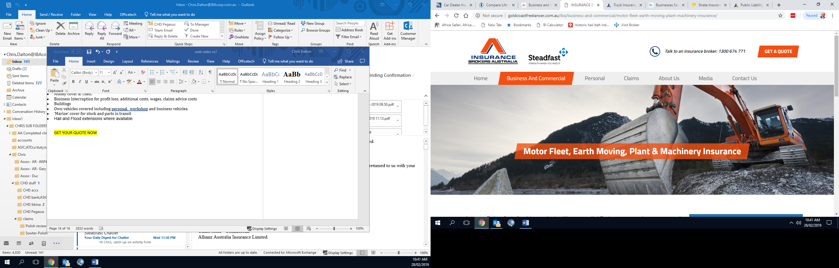

## Covering all eventualities

 Equipment and machinery form the backbone of your business operations. Should there be damage or theft your business will suffer serious interruption; in some cases losing associated plant and machinery capabilities could even end the viability of your operation.

Plant and machinery insurance allows you to carry on, without the crippling loss to your cash flow. In some instances you may even be able to claim for legal expenses and the costs of business interruption.

Whether you own your plant and machinery or are hiring the equipment from a third party, plant and machinery insurance is vital in helping you ensure you are covered against all eventualities.

We work with our network of leading Australian and Lloyd’s insurance partners to safeguard your business and operations in many sectors-

* Construction
* Manufacturing
* Engineering
* Demolition including asbestos
* Factory
* Landscaping, fencing and gardening
* Farming and agriculture

Whatever machinery your business relies on, we can help protect:

* Bobcats, trenchers and backhoes
* Forklifts
* Compactors
* Loaders
* Mobile working platforms
* Dumpers
* Diggers
* Loaders
* Bulldozers
* Rollers

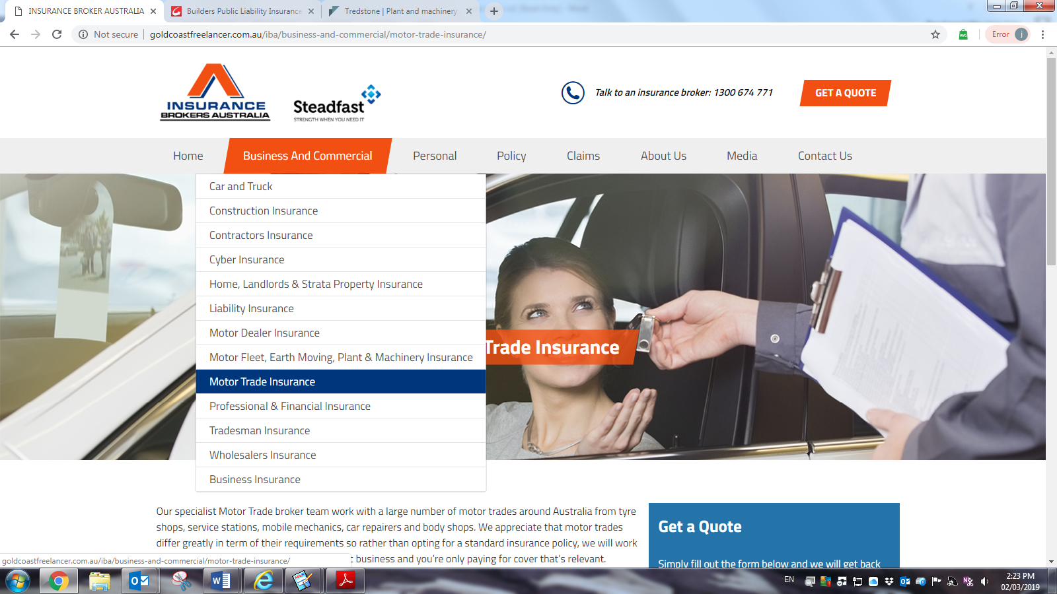

**Who needs motor trade insurance?**

**When your business involves**

* **staff driving your customers’ vehicles**
* **staff driving your own vehicles**
* **customers driving loan vehicles**
* **whisking on wheels**
* **patching up panels**
* **mixing with motors**

**you’ll need our tailored motor trade pak to protect you financially against any accidents or mishaps.**

check out our video guide:  
  
<https://youtu.be/ZpmOnq3IUiA>

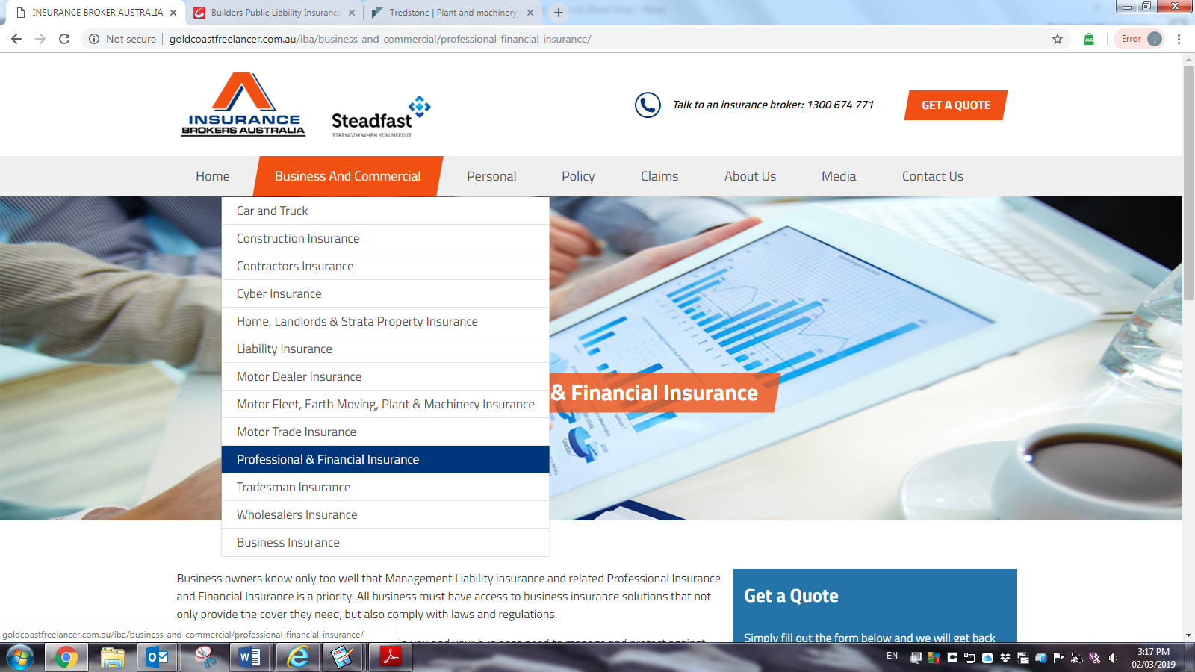

The businesses we assist most often-

* Professional Services (incl. Accountants, Real Estate, Engineers, IT)
* Manufacturing and Distribution
* Media (incl. Printing, Publishing, Entertainment)
* Medical
* Retail
* Services (incl. Community Services, Call Centres, Beauty Therapy)
* Tourism and Hospitality (incl. Cafes, Restaurants, Travel
* Trades

Our various policy covers in the market are specifically designed to protect your SME business for the management risks when operating in today's often complex and litigious world.

Not all Management Liability offerings are the same, and our brokers understand there are differences between insurer's products, and the impact of these differences for our clients. Our broker’s Management Liability policies offer broad coverage including high sub-limits and competitive premiums- our policies will most often include these covers-

* Entity Cover – Full Policy Limit
* Employment Practices Liability – Full Policy Limit
* Crime - Sub-Limited
* ATO Tax Audit Costs - Sub-Limited
* Official Investigations & Inquiries – Full Policy Limit, for both Insured Persons and Entity
* Occupational Health & Safety Defence Costs - Sub-Limited, for both Insured Persons and Entity
* Statutory Liability - Sub-Limited

AND policies can also be extended to include:

* ATO Risk Reviews - Sub-Limited
* State & Territory Tax Audits - Sub-Limited







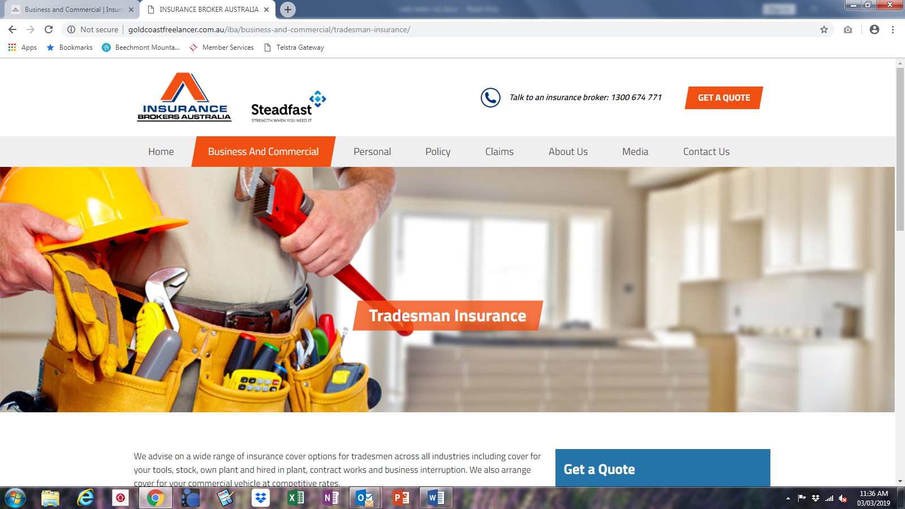

<https://www.towergateinsurance.co.uk/tradesman-insurance?utm_campaign=googleppc&gclid=EAIaIQobChMI5dDei-zk4AIVlIWPCh1h8QU1EAAYAiAAEgJckfD_BwE&gclsrc=aw.ds>

Features of our tradesman insurance

**Tailored cover**

Our trades brokers understand the subtle differences in requirements between trades, so they can tailor your policy accordingly. Our policies also remain flexible as you grow, so as you take on employees, purchase new equipment or take on larger contracts, you can adjust your cover.

**Specialist cover**

Many insurers have trouble providing some of the more specialist types of cover such as ‘contractors all risks’ (CAR) cover for your own plant, hired-in plant, and contract works cover. Our brokers however, can source policies which include many of these features combined. We can even provide trade specific cover such as professional indemnity depending on the nature of the work you do.

**Liability and professional indemnity cover**

Whether you’re a one man band or have a team of employees; whether you’re doing a bit of gardening or taking on a large public contract, liability insurance is the most important cover you’ll have. We can provide public, product and employers’ liability insurance as you need with Certificates of Currency for each protection.

**Tradesman tools cover**

Our flexible options for tools cover protects your own tools if you want or need to, but you can also get cover for your employees’ tools while they’re working for you and also cover for any specialist plant you hire out too [dry hire]….even if you leave your tools locked away on site, or in your van or home garage.

Tradesman Insurance Claims

When it comes to the crunch and you need to claim, we'll liaise with the insurer to get your matters resolved as quickly as possible.

If there are complications, we’ll follow this up with the insurer and update you with the progress.

Need to make a claim?

Call or email with your policy number, a phone number to reach you on, details of your loss and photos where possible

1300 674 771- claims@IBAcorp.com.au

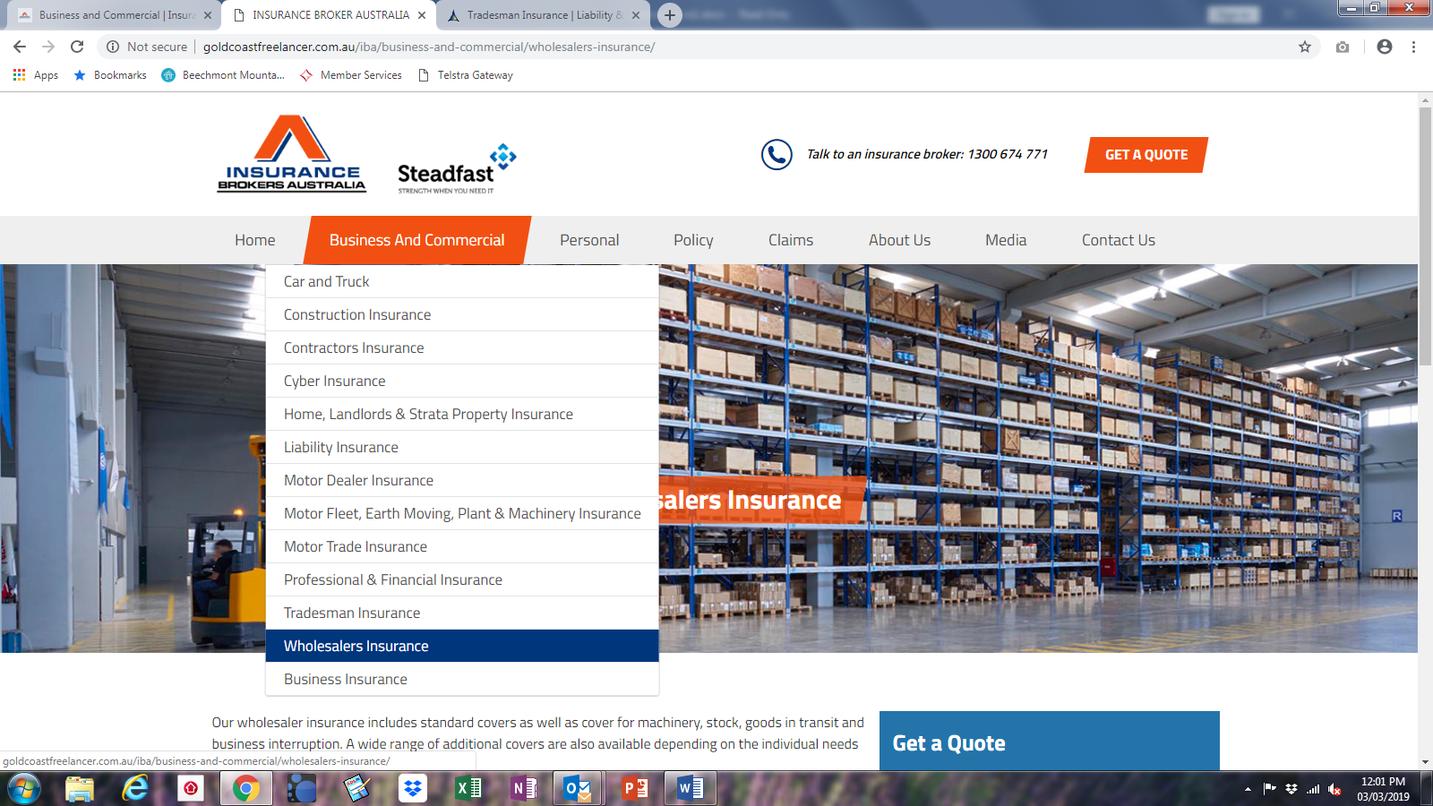

<http://www.uk-commercial-insurance.com/wholesalers-insurance/>

**Wholesalers Insurance**

**Wholesalers Insurance Quotes**

Wholesaling and the utilisation of wholesalers warehousing facilities are ever increasing. Our brokers are able to cover all Australian wholesaling liability, property, transportation, storage and stock risks with our specialist commercial polices for all types of wholesaler -

• Catering Equipment   
• Cash and Carry   
• Clothing   
• Computers   
• Fancy Goods   
• Fish, Meat & Poultry   
• Flowers   
• Fruit and Vegetable   
• Food & Drink   
• Leather Goods   
• Office Equipment   
• Paint   
• Wines, Spirits and Alcohol

**ABOUT WHOLESALERS INSURANCE**  
**Wholesalers Covers Available**  
Our wholesalers commercial polices allow you to choose from full property and liability cover –  
Material Damage, Business Interruption, Accidental Damage, Goods in Transit, Stock, Liability Cover, Money, High Stock Sum Insured, Stock of Leather options, Textiles Included, USA Exports,

There are many types of commercial insurance that offer valuable protection to any Wholesale business.

**Options to include in your policy pak**

* **Buildings**   
  The wholesale business premises should be insured for their full rebuilding cost and not just for their market value. You may need expert advice to calculate the rebuilding cost, which often differs significantly from market value
* **Contents and Stock**  
  Your stock should be insured for its cost price without any addition for profit. Provision can be made for seasonal stock fluctuations.  
  Plant and business equipment can be insured for “replacement” basis.
* **Business interruption**  
  Damage to your property or machinery, or loss of stock, will seriously disrupt your business leading to loss of income and additional expenses.  
  Similar loss or damage at the premises of your suppliers or customers may impact your own business and so consider taking out cover for such eventualities.  
  Business interruption insurance will compensate for the short-fall in gross profit together with paying any increased working costs and extra accountants’ fees incurred.
* **Engineering (breakdown of machinery and electronic equipment)**  
  Engineering insurance provides cover against electrical or mechanical breakdown for most machinery, including computers, phone systems, air conditioning equipment and the like.
* **crime**  
  theft of plant, contents, money, and stock including damage to the building resulting from theft will also be covered. Theft by employees is usually not covered – cover against employee dishonesty can be arranged by a fidelity guarantee policy.
* **Public liability**  
  providing cover against an occurrence for which you would be legally liable relating to bodily injury or loss or damage to property arising in the course of your business.
* **Product liability**  
  providing cover for you against legal liability incurred as a result of a product or service manufactured or supplied being faulty or defective and causing loss or injury to a person or a business.
* **Goods in transit**  
  cover against loss or damage while in your vehicle or when sent by carrier.
* **Credit**

cover against customers who fail to pay their invoices.

* **fidelity**  
  covers for fraud or dishonesty by employees; it can be taken out for specific employees or the whole staff.
* **management**  
  Business owners know only too well that Management Liability insurance and related Professional Insurance and Financial Insurance is a priority. All business must have access to business insurance solutions that not only provide the cover they need, but also comply with laws and regulations.

This will include protection for-

* Entity Cover
* Employment Practices Liability
* Crime
* ATO Tax Audit Costs
* Official Investigations & Inquiries
* Occupational Health & Safety Defence Costs
* Statutory Liability
* ATO Risk Reviews
* State & Territory Tax Audits

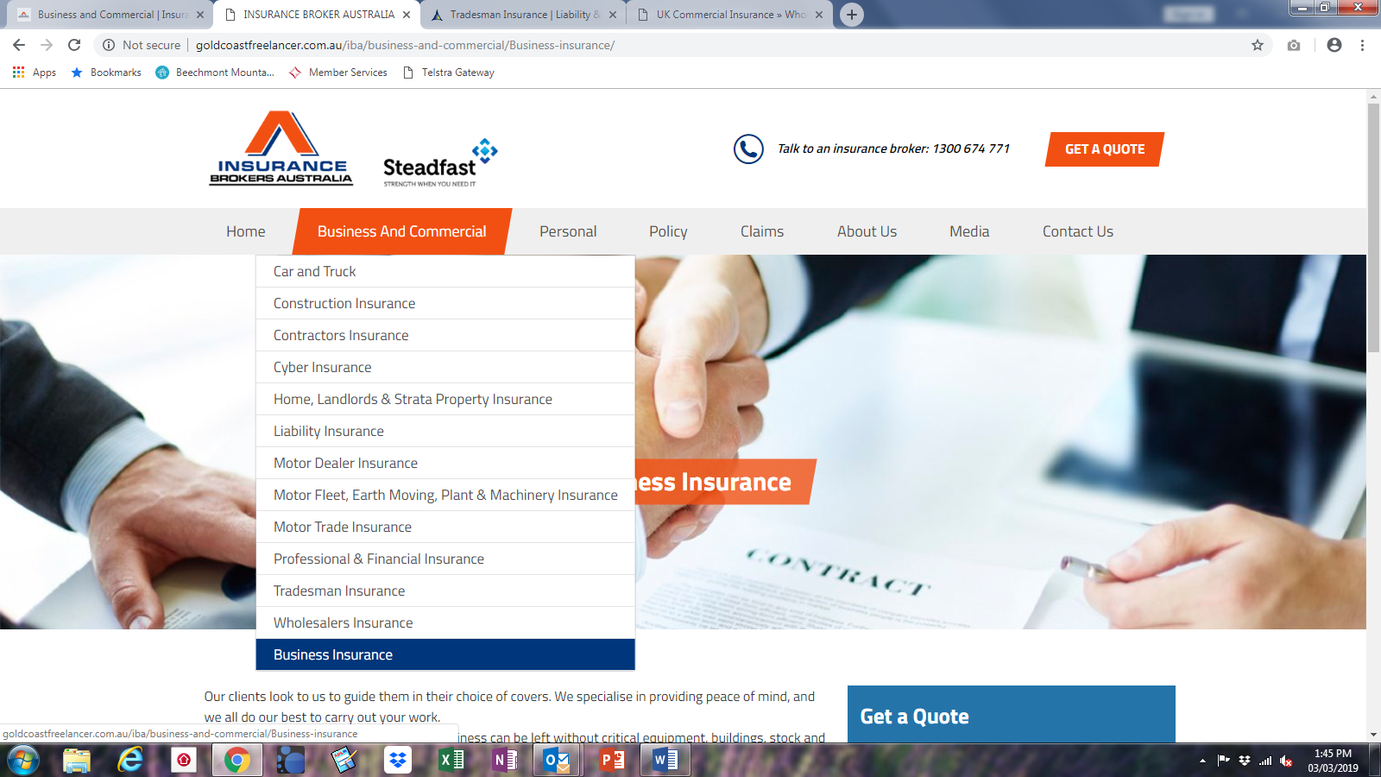

Our business is your business-

So we know how to protect your business from the risks you face

Our business brokers, will guide you in your choice of covers. We specialise in providing peace of mind by making sure you’re protected at every turn with the right business insurance.

Although we all do our best to carry on our business error-free, accidents and mistakes do happen. Any business can be left without critical equipment, vulnerable to online attack, or exposed to claims of negligence, injury or property damage.

Choose the products that are right for your business and create one single and comprehensive insurance package, tailored to your requirements.

GET YOUR QUOTE NOW

<https://www.hiscox.co.uk/business-insurance>

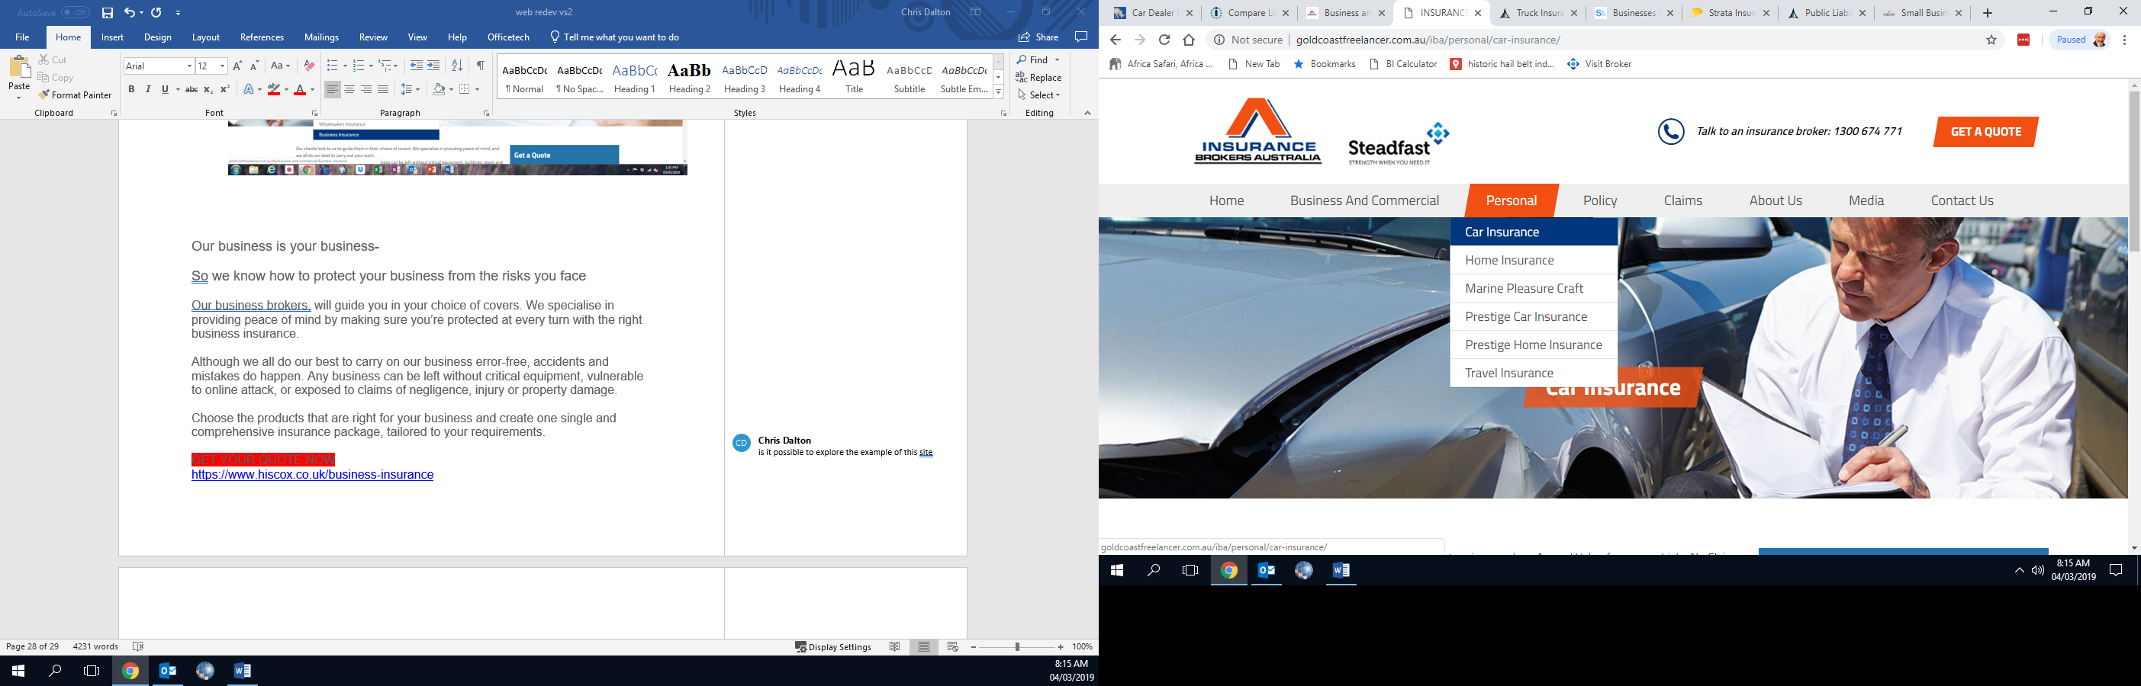

Our motoring brokers search a panel of carefully selected insurers to give you the best balance of competitive price and comprehensive cover. With years of continuous experience serving our clients, you know you’re in safe hands.

Policy benefits and features will vary from cover to cover so ask our brokers when arranging your cover how extensive your features are vs the ‘cheap’ policies on offer in the direct insurer market.

Making a claim is straight forward when dealing with your broker and ‘getting it right’

Policy benefits and features we most frequently offer-

<https://www.allianz.com.au/car-insurance/car-insurance-comparison/>

|  |  |  |  |
| --- | --- | --- | --- |
| **If you have a claim under this policy we give benefits for:** | **Comprehensive cover** | **Third Party Property Damage, Fire & Theft cover** | **Third Party Property Damage cover** |
| Cover for damage to other people's property (legal liability cover) | $20 million* | $20 million* | $20 million* |
| Approved legal costs arising out of a covered loss under your policy |  |  |  |
| Legal liability cover when using a substitute vehicle |  |  |  |
| Damage to your car if you are not at fault in an accident and the other vehicle is uninsured |  | Up to a market  value of $5,000 | Up to a market  value of $5,000 |
| Reasonable costs of towing after a covered accident, fire or theft |  | Fire & theft only value of $5,000 |  |
| Accidental loss or damage to your car caused by fire or theft |  | Up to a market  value of $5,000 |  |
| Cover for accidental damage or loss to your car (caused by events other than fire or theft) |  |  |  |
| New replacement car if your new car (less than two years old from original registration) is a total loss |  |  |  |
| Rental car following theft ($100 per day limit, up to 21 days) |  |  |  |
| Supplementary Bodily Injury | $20 million* | $20 million* | $20 million* |
| Cost of emergency repairs | Up to $500 |  |  |
| Reasonable emergency accommodation and travel expenses | Up to $750 |  |  |
| Accidental damage to or theft of personal effects and clothing | Up to $750 |  |  |
| Replacement of any Child Seat or Baby Capsule in the vehicleafter a covered accident | Up to $500 |  |  |
| Lock re-keying and re-coding if keys to your vehicle are stolen | Up to $1,000 |  |  |
| Reimbursement of transportation costs if you vehicle cannot besafely driven home after a covered accident | Up to $500 |  |  |
| Accidental loss or damage to trailer or caravan attached to your vehicle at the time of the covered accident | Up to $1,000 |  |  |
| Star Rating Protection | Optional |  |  |
| Removal of basic excess on windscreen claim | Optional |  |  |
| Rental car following an accident ($100 per day limit, up to 21 days) | Optional |  |  |
| Tools of Trade (up to $3,000) | Optional |  |  |

OR

Alternately a simple version from the Steadfast sight below-

Quality cover to get you back behind the wheel faster

Whether you’re zipping around the city in a small car or motorbike, taking your SUV off-road on the weekends, delivering goods in a truck, or driving a sleek luxury model, you depend on your vehicle for freedom and flexibility.

So it’s great to know that if it gets damaged or is written off, you’ve got the cover you need to get you back on the road as soon as possible.

Motor insurance includes a range of covers to suit every driver and vehicle type, and can be paid annually or by the month.

Who needs it?

If you have a car, it makes sense to protect yourself against unexpected costs with car insurance.

That’s because accidents can be costly – especially when you’re at fault. If your car is involved in an accident you caused, you’ll not only have the expense of repairing your own car – you’ll generally have to pay for damage to the other vehicle too.

What does it cover?

The cover provided by comprehensive insurance can vary, depending on the policy. But here are some examples of possible cover:

* Replacement of a lost or stolen vehicle
* Cover to help pay for the damage you’ve caused to another person’s vehicle
* Cover for the cost of a rental care if your car needs repairing or gets stolen
* A replacement of the same make and model for new cars that are written off within three years
* Legal liability cover
* Re-keying or re-coding of vehicle keys that are stolen.

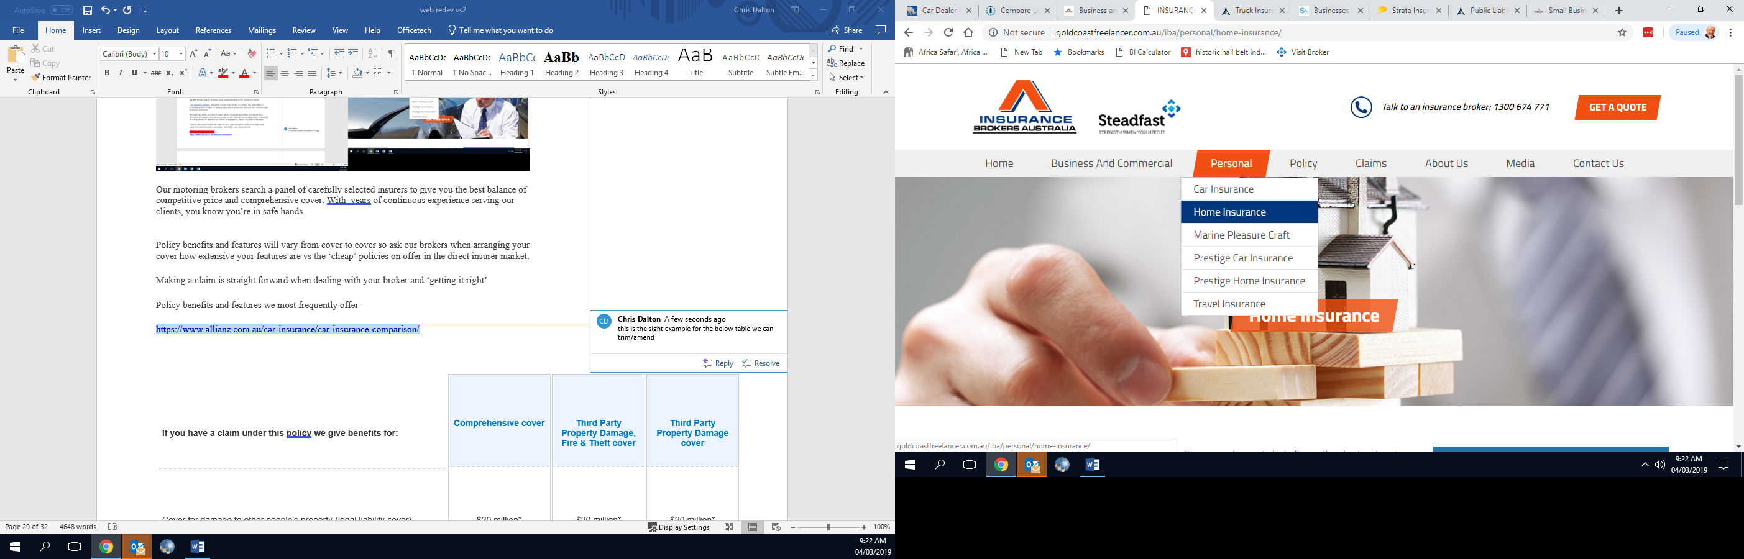

**<https://www.steadfast.com.au/insurance-types/personal-insurance/home-and-contents-insurance>**

Your home is your sanctuary – so make sure you help protect it

Your home is far more than a physical asset. Home is safety, security, familiarity and comfort – so an extreme weather event, accident or home invasion could cost you more than a material loss.

That’s why it makes good sense to help protect your precious home with quality insurance – and make sure you have the right type and amount of cover to help keep your home and possessions safe.

Who should consider it?

If your home and its contents were damaged or destroyed or your possessions stolen, and you couldn’t afford to replace them yourself, you should consider home and contents cover.

If you have a mortgage, your bank usually requires that you have Home Insurance over your home. But even if you own your home outright, have an investment property, or rent your home, you should consider some type of home insurance.

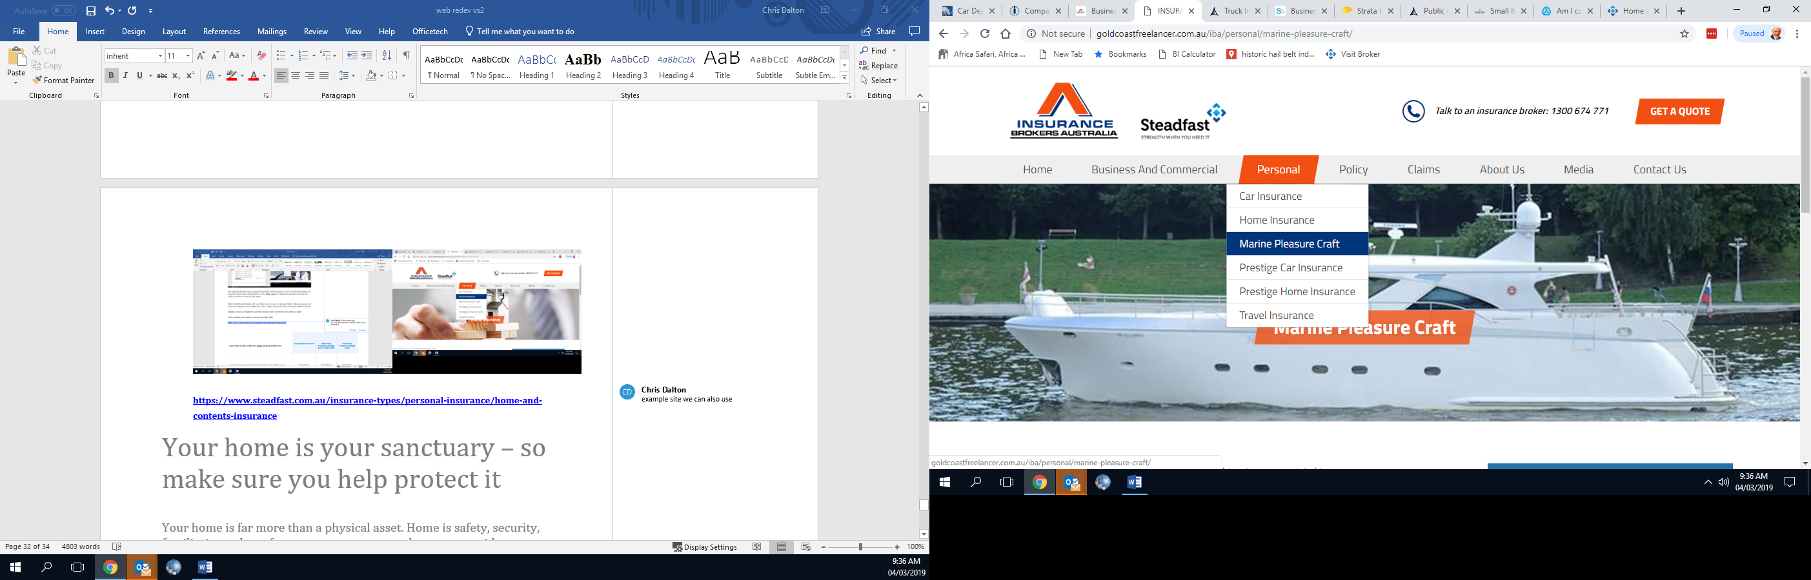

**<https://www.towergateinsurance.co.uk/boat-insurance>**

**Boat Insurance**

Boat insurance for a wide variety of craft, covering a range of risks. Call us to speak with our friendly team

* Accidental damage available across all our boat insurance policies
* Flexible levels of protection to suit you
* Advice and assistance from a dedicated team of experts

[Motor Boat](https://www.towergateinsurance.co.uk/motor-boat-insurance" \o "Motor Boat Insurance)

**[MOTOR BOAT](https://www.towergateinsurance.co.uk/motor-boat-insurance" \o "Motor Boat Insurance)**

**[Get a quote](https://www.towergateinsurance.co.uk/motor-boat-insurance" \o "Motor Boat Insurance)**

**Get a £40 Amazon voucher and 10% discount on boat insurance**

[Jet Ski](https://www.towergateinsurance.co.uk/jet-ski-insurance)

**[JET SKI](https://www.towergateinsurance.co.uk/jet-ski-insurance" \o "Jet Ski  Insurance)**

**[Get a quote](https://www.towergateinsurance.co.uk/jet-ski-insurance" \o "Jet Ski  Insurance)**

**Get a £40 Amazon voucher and 10% discount on boat insurance**

[Yacht](https://www.towergateinsurance.co.uk/yacht-insurance)

**[YACHT](https://www.towergateinsurance.co.uk/yacht-insurance" \o "Yacht Insurance)**

**[Get a quote](https://www.towergateinsurance.co.uk/yacht-insurance" \o "Yacht Insurance)**

**Get a £40 Amazon voucher and 10% discount on boat insurance**

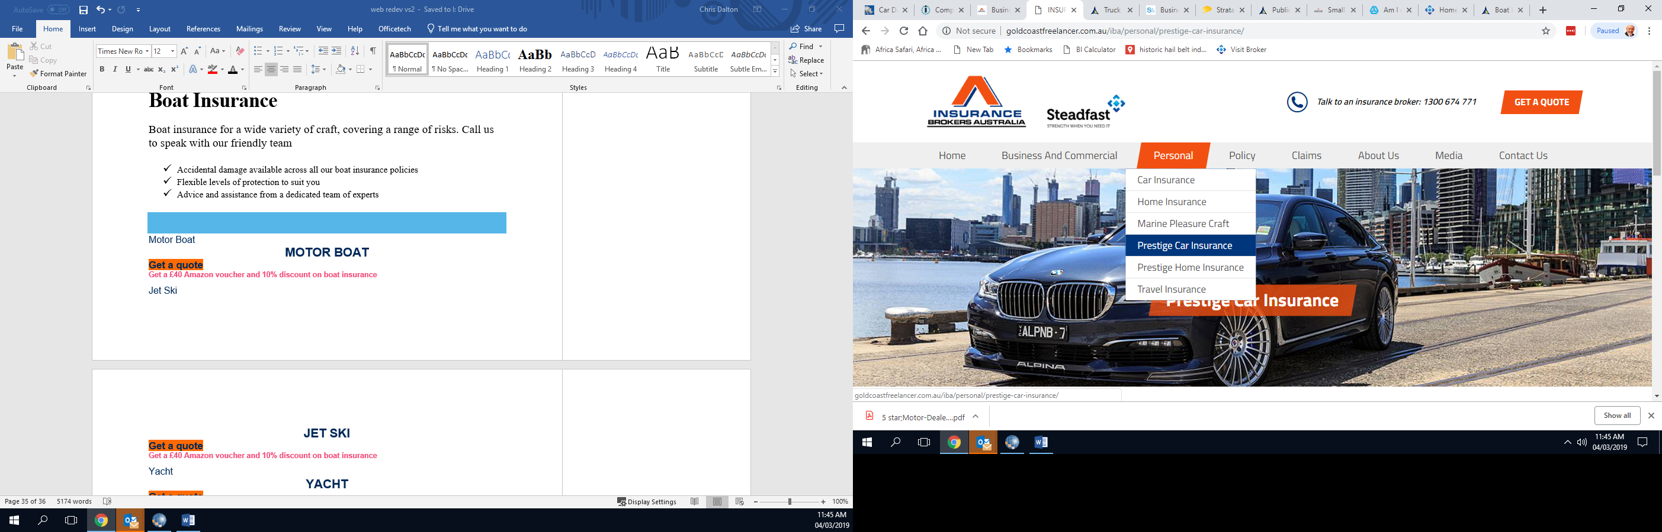

if it is

* Exotic
* ‘high-end’
* Classic
* Modified
* custom-built
* prestige luxury
* Or any make of motorcycle,

we understand that cars and bikes are as important as the people who drive them.

Highly regarded for arranging insurance for some of the more unique vehicles including high performance import vehicles, hot rods, stretch limousines and off-road dirt bikes, we are dedicated to arranging cover through specialist insurers

for specialist vehicle risks.

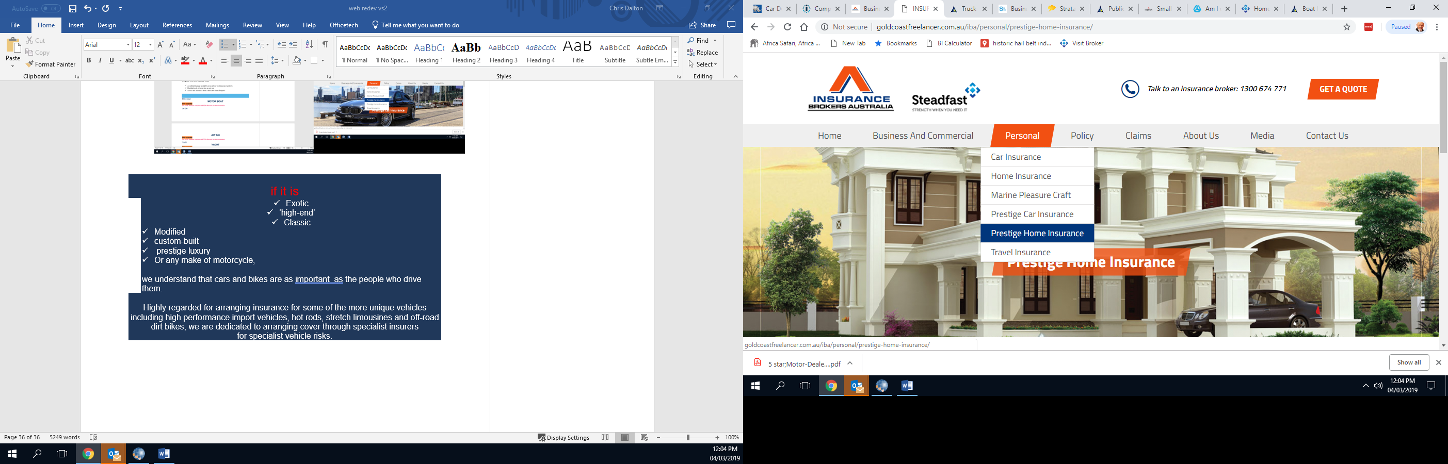

**<https://steadfastagencies.com.au/our_agencies/mansions-of-australia/>**

**our brokers are passionate about the high level of service we continue to provide all our prestige home owners… you will not find a que from a call centre in front of you.**

Not all insurance companies offer the same benefits, so it’s important to know what you are getting before risking your most prized possessions with a low-cost home and contents policy.

**…speak to our brokers today or send details**





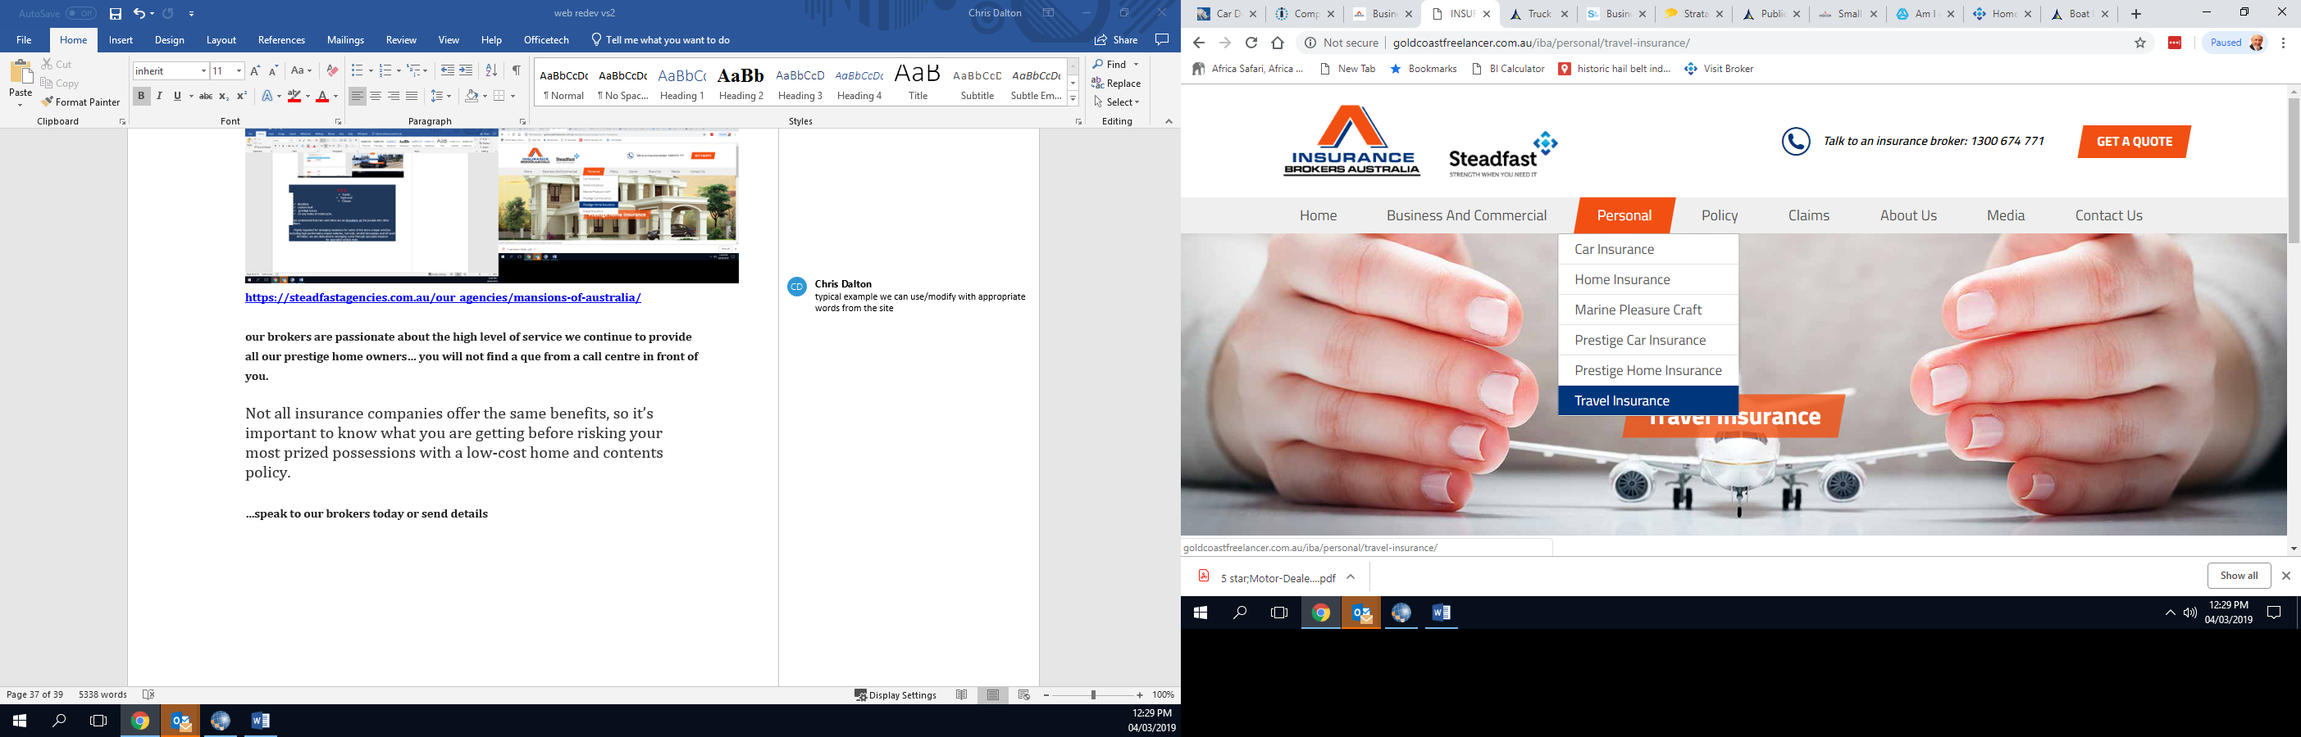

**<http://goldcoastfreelancer.com.au/iba/travelcard-comprehensive-leisure-international-travel-insurance/>**

We hope your travels are everything you are dreaming of and rest assured that we have got the back of every policyholder covered… we serve and will treat everyone like one of our family.

Our brokers have formed a unique offering with ‘Travelcard’ to offer a unique set of features, benefits and premium savings, offering products and services unlike anything else in the travel market…. They are the ‘good guys’ doing what is great for clients and making life easy.

* Market Leading Benefits across all our Real Time Travel Insurance products.
* Real-Time claims approval and payment, while you’re still travelling, without endless paperwork.
* A customer experience you will be pleased to talk about with colleagues, friends and family. We actually hope to be the first travel insurance and assistance team you can fall in love with.

Please remember, the Travelcard help lines are here for you 24/7 and always happy to hear from you…and help you!

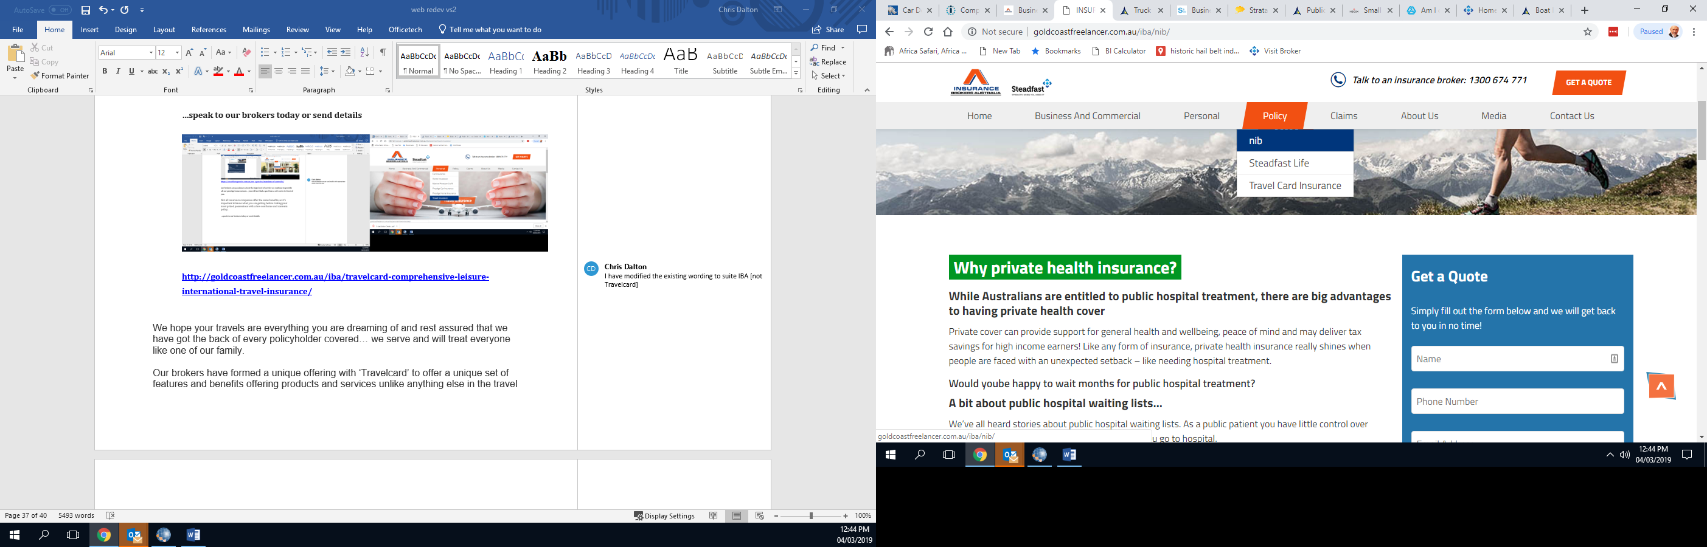

<http://goldcoastfreelancer.com.au/iba/nib/>

Once again our brokers have developed a unique way of helping our clients with what we all agree has been one of the least understood and complex ‘insurances’ we need to deal with –

a unique offering with ‘nib’ to offer features, benefits and premium savings, on products and services unlike anything else in the health field…. they are good at what they do which is great for you and makes life easy.

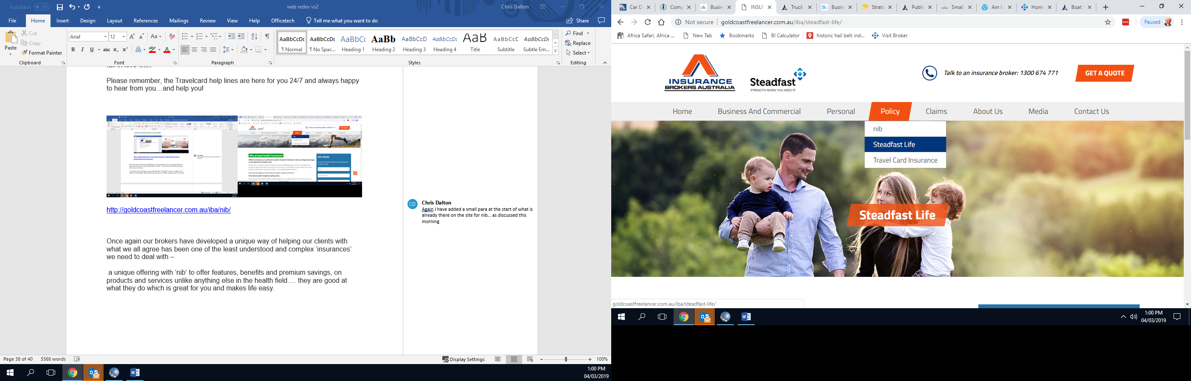

We don’t know what’s around the corner

Even the best-planned life can come undone by illness, accident or death – and often with far-reaching consequences for our family or business partners who depend on us.

Having the safety net of life insurance in place is critical to ensure those who depend on you can keep going without you.

Of course extra cover is able to protect your financial future should you be seriously ill or injured, or permanently disabled.

Is it for me?

Life cover is recommended for business owners and anyone with financial dependants.

Even those without dependants can benefit if they become terminally ill. What’s more, total and permanent disability (TPD) cover can provide a payment if you become permanently disabled.

What can it cover?

a range of different covers:

* Business life insurance for SMEs, such as key person insurance, income protection, b-sell insurance, guarantor protection and business expenses insurance
* Group life insurance, which provides benefits for employees
* Personal life cover, and ‘TPD’ cover.

Product Disclosure Statement

A Product Disclosure Statement (PDS) is available for the Life covers.

You should consider the PDS in deciding whether to acquire, or continue to hold, Life Insurance

Speak to a broker

it’s important to make sure those who depend on you have a safety net. To find out more about your options, talk to any of our brokers today. They can help you choose the right type and amount of cover for your circumstances.

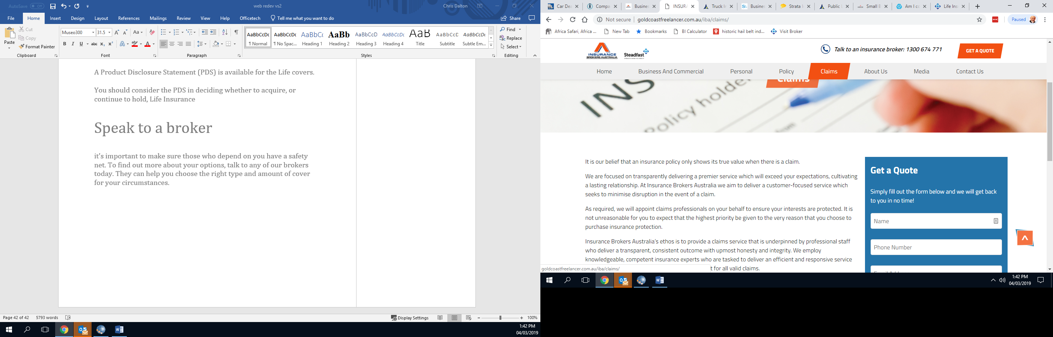



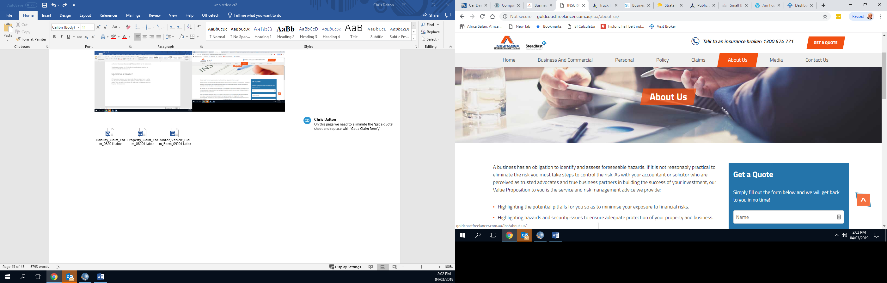

In 1996, 43 privately owned Australian insurance brokerages joined forces, united with the ambition that quality advice and service were paramount in the insurance industry. With that ‘**Steadfast’** was born, an Australian owned and operated enterprise, now an ASX 200 listed company. [**SDF**]

Today **Steadfast** are the largest general insurance broker network and group of underwriting agencies in Australasia, with growing operations in Asia, Europe and 348 brokerages with over 1,200 offices across metropolitan and regional Australia and New Zealand.

Steadfast are an ASX 200 listed company, a market leader in theindustry and an innovator in insurance broking. True to their original charter, Steadfast exists to drive an insurance broker network that provides unique professional services and advice to its clients.

Steadfast generated A$6 billion in sales in the last FY and the group looks after over 2 million policies for Australian and New Zealand businesses.

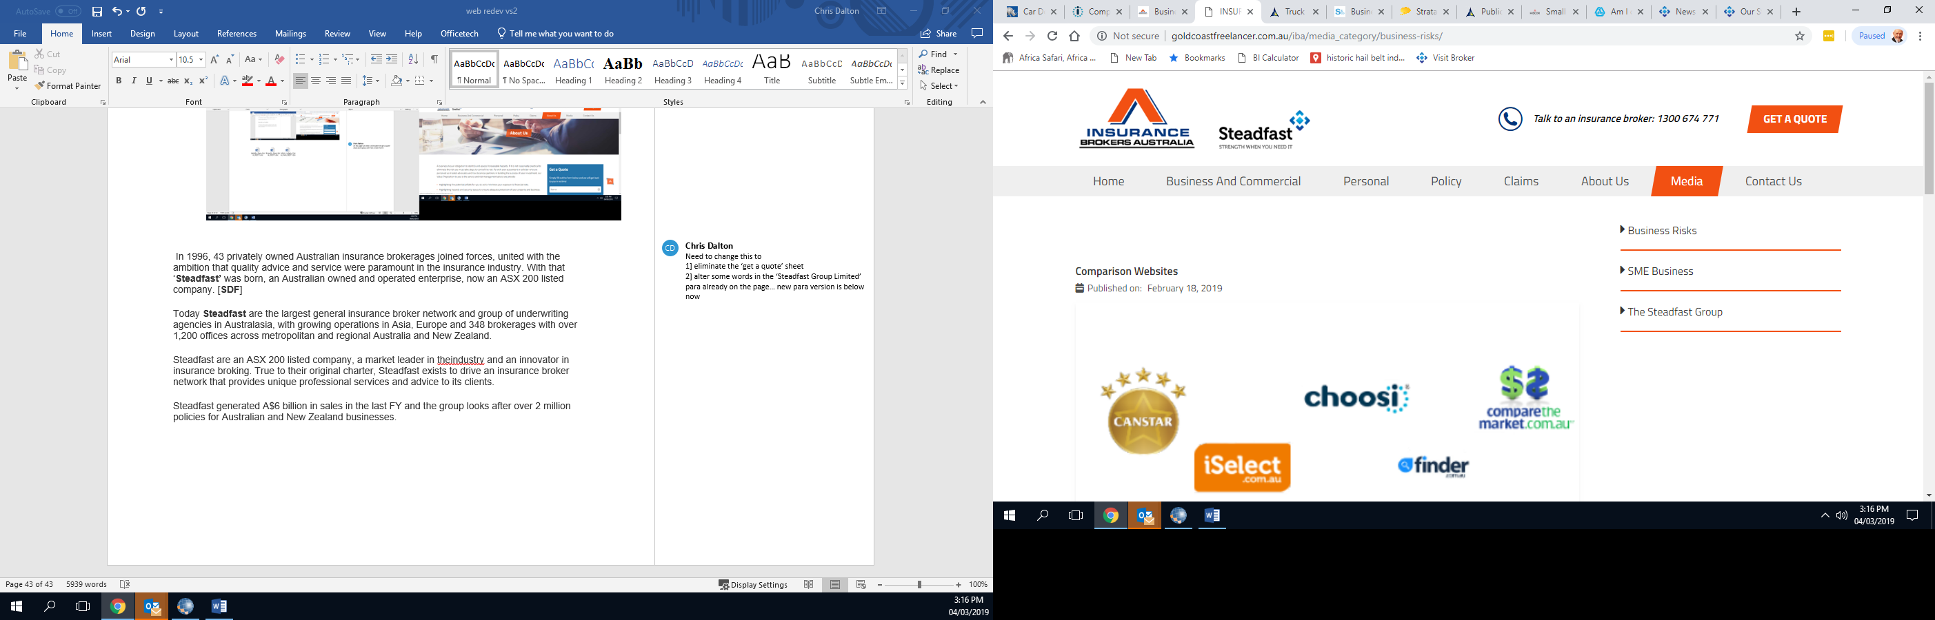

<https://www.steadfast.com.au/well-covered>

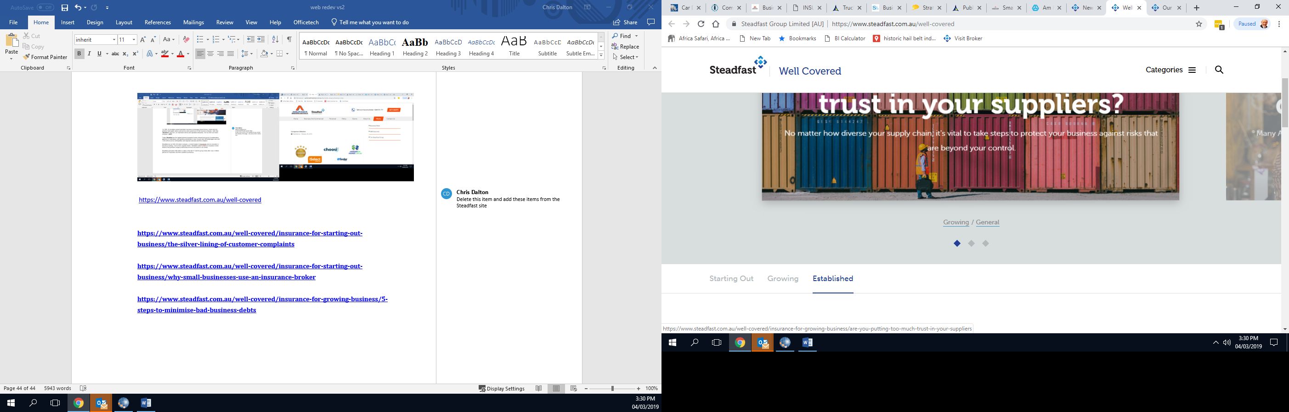

**“STARTING OUT”**

[**https://www.steadfast.com.au/well-covered/insurance-for-starting-out-business/the-silver-lining-of-customer-complaints**](https://www.steadfast.com.au/well-covered/insurance-for-starting-out-business/the-silver-lining-of-customer-complaints)

[**https://www.steadfast.com.au/well-covered/insurance-for-starting-out-business/why-small-businesses-use-an-insurance-broker**](https://www.steadfast.com.au/well-covered/insurance-for-starting-out-business/why-small-businesses-use-an-insurance-broker)

[**https://www.steadfast.com.au/well-covered/insurance-for-growing-business/5-steps-to-minimise-bad-business-debts**](https://www.steadfast.com.au/well-covered/insurance-for-growing-business/5-steps-to-minimise-bad-business-debts)

[**https://www.steadfast.com.au/well-covered/insurance-for-starting-out-business/the-customers-your-business-needs-to-avoid**](https://www.steadfast.com.au/well-covered/insurance-for-starting-out-business/the-customers-your-business-needs-to-avoid)

[**https://www.steadfast.com.au/well-covered/insurance-for-starting-out-business/lesson-learned-from-fighting-a-fire**](https://www.steadfast.com.au/well-covered/insurance-for-starting-out-business/lesson-learned-from-fighting-a-fire)

[**https://www.steadfast.com.au/well-covered/insurance-for-starting-out-business/5-tech-savvy-ways-to-prevent-tools-being-stolen**](https://www.steadfast.com.au/well-covered/insurance-for-starting-out-business/5-tech-savvy-ways-to-prevent-tools-being-stolen)

**“GROWING”**

[**https://www.steadfast.com.au/well-covered/insurance-for-growing-business/5-steps-to-minimise-bad-business-debts**](https://www.steadfast.com.au/well-covered/insurance-for-growing-business/5-steps-to-minimise-bad-business-debts)

[**https://www.steadfast.com.au/well-covered/insurance-for-growing-business/lessons-learned-from-sydneys-catastrophic-storm**](https://www.steadfast.com.au/well-covered/insurance-for-growing-business/lessons-learned-from-sydneys-catastrophic-storm)

[**https://www.steadfast.com.au/well-covered/insurance-for-growing-business/5-ways-to-ensure-your-business-does-not-stumble-trip-and-fall**](https://www.steadfast.com.au/well-covered/insurance-for-growing-business/5-ways-to-ensure-your-business-does-not-stumble-trip-and-fall)

[**https://www.steadfast.com.au/well-covered/insurance-for-growing-business/how-to-create-and-maintain-an-smb-inventory-list**](https://www.steadfast.com.au/well-covered/insurance-for-growing-business/how-to-create-and-maintain-an-smb-inventory-list)

[**https://www.steadfast.com.au/well-covered/insurance-for-growing-business/four-steps-to-appeal-a-rejected-insurance-claim**](https://www.steadfast.com.au/well-covered/insurance-for-growing-business/four-steps-to-appeal-a-rejected-insurance-claim)

[**https://www.steadfast.com.au/well-covered/insurance-for-starting-out-business/the-tradies-guide-to-insurance**](https://www.steadfast.com.au/well-covered/insurance-for-starting-out-business/the-tradies-guide-to-insurance)

[**https://www.steadfast.com.au/well-covered/insurance-for-starting-out-business/why-small-businesses-use-an-insurance-broker**](https://www.steadfast.com.au/well-covered/insurance-for-starting-out-business/why-small-businesses-use-an-insurance-broker)

[**https://www.steadfast.com.au/well-covered/insurance-for-starting-out-business/how-to-protect-your-business-from-bad-advice**](https://www.steadfast.com.au/well-covered/insurance-for-starting-out-business/how-to-protect-your-business-from-bad-advice)

[**https://www.steadfast.com.au/well-covered/insurance-for-starting-out-business/what-you-need-to-know-about-landlord-insurance**](https://www.steadfast.com.au/well-covered/insurance-for-starting-out-business/what-you-need-to-know-about-landlord-insurance)

**“ESTABLISHED”**

[**https://www.steadfast.com.au/well-covered/insurance-for-established-business/how-to-reduce-your-business-insurance-costs**](https://www.steadfast.com.au/well-covered/insurance-for-established-business/how-to-reduce-your-business-insurance-costs)

[**https://www.steadfast.com.au/well-covered/insurance-for-established-business/how-to-reduce-the-risk-of-losing-out-to-employee-theft**](https://www.steadfast.com.au/well-covered/insurance-for-established-business/how-to-reduce-the-risk-of-losing-out-to-employee-theft)

[**https://www.steadfast.com.au/well-covered/insurance-for-established-business/trust-is-priceless-dont-lose-it**](https://www.steadfast.com.au/well-covered/insurance-for-established-business/trust-is-priceless-dont-lose-it)

[**https://www.steadfast.com.au/well-covered/insurance-for-established-business/keeping-contractors-safe-while-on-premises**](https://www.steadfast.com.au/well-covered/insurance-for-established-business/keeping-contractors-safe-while-on-premises)

[**https://www.steadfast.com.au/well-covered/insurance-for-established-business/privacy-law-changes-are-here-is-your-sme-ready**](https://www.steadfast.com.au/well-covered/insurance-for-established-business/privacy-law-changes-are-here-is-your-sme-ready)

[**https://www.steadfast.com.au/well-covered/insurance-for-starting-out-business/the-tradies-guide-to-insurance**](https://www.steadfast.com.au/well-covered/insurance-for-starting-out-business/the-tradies-guide-to-insurance)